Hello Everyone
Please find an outline of work for the coming week.
This week we will be working on addition with renaming or regrouping; where the number of ‘units’ in a problem ends up being 10 or more and we need to change some ‘units’ into ‘tens’. I have attached a step by step explanation of how to do the addition sums and a few examples to follow. We have done a few in school but it’s been a while, so take it slowly and they will be fine
Please use the ‘Reading Eggs’ programme daily.
This week I would like to see a photo of two pieces of work from everyone:
Bua na Cainte page 82;
Busy at Maths page 146.
I can be emailed on firstclassbweeng2020@gmail.com
I really do enjoy seeing the lovely pictures and videos of all of the work and activities that you have been doing. I am so proud of all of your work and I can’t wait to see you all again. I really love seeing how everyone is doing so keep in touch
Stay safe everyone
Miss Buckley
 | Monday | Tuesday | Wednesday | Thursday | Friday
Spellings | 1st group | 2nd group | 3rd group | 4th group | Spelling test
Spellbound | Activity a + b | Activity c + d | Activity e + f | Activity g + h
Tables week 26 | Monday (-9) | Tuesday (-9) | Wednesday (-9) | Thursday (-9) | Tables test
Maths | P144  Regrouping  Making a bundle of ten when the units get too big | P145:  Regrouping | P146:  Regrouping | P148:  Regrouping | Sheet  Regrouping tens
Reading  Denzels Holiday | P39 | P40 | P41 | P42 | Poem: The skateboard twins and worksheet
Recorder:  10 minutes every day | Play the scale and one of the tunes in your list of songs
English | All Write Now page 46  qu revision | Skills Book E page 52  Colour matching words | All Write Now page 47  y sound = ee sound | Skills Book E page 53  Capital letters | All Write Now page 48  x,v,w revision
SESE | Small World:  page 21:  Weather forecasts long ago | Small World  page 30/31:  cows and milk | Small World  page 59:  the farm: milking | Small World pages 58:  The farm: tractors
Gaeilge | Reading page:  An Carnabhal | Poem:  Ag Scipeáil  Bua na Cainte:  Page 83 dathaigh an pictiúr | Reading page:  Caifé Coco | Bua na Cainte Page 82  Scríobh An Nuacht | Reading page:  Lachain Bheaga

Extra activities for the week if you need them.
- Nuacht / News time: discuss the weather; what day is it today/ tomorrow/ yesterday; what month/ season it is; what activities you have done in the previous few days; places you would like to visit.
Cén lá atá againn inniu? Inniu an ____________
Cén lá a bhí againn inné? Inné an ____________
Cén lá a bheidh againn amárach? Amárach an ____________
Cén sort aimsir atá againn? Tá an lá ________
- Keep a daily diary of what you did/made today
- Fr Coleman will be saying mass each Sunday at 11am (available online on the Glantane Facebook page). He will be including some of the Communion prayers and hymns in the masses if you would like to listen in and practice the responses, prayers and hymns. Next Sunday the 24th of May he will be offering the Mass for the Communion children.
- RTE Home school hub has lessons daily from 11am to 12 noon
- TG4 has daily lessons from 10am to 11am
- Extra English Reading: Read at home 1 book (online CJFallon)
- Reading Eggs: spend 30 minutes daily doing reading and activities
- Tables race: write out a list of sums and time yourself to see how fast you can do them
- Lego 30 day challenge
- Reading: Spend 30 minutes daily on www.readingeggs.com completing reading and phonics activities
- ‘The Body Coach’ on Facebook or ‘PE with Joe’ on Youtube have 30 minute workouts available daily online
- www.fyffesfitsquad.ie will start daily fitness sessions at 10am
- ‘Go Noodle’ or ‘Just Dance’ have a range of activities that can be completed indoors
- With the toys or PE gear you have in your house, make an obstacle course for your family. Time each other completing the course
- With a skipping rope, see how high you can count up to in Irish (like in the Ag Scipeáil poem)
- Run/jog/walk 2km and time yourself doing it. Each time you complete the 2km try to beat your previous time.
- Bake some of the recipes that we have made in school already or try a new recipe out and teach us when we are back in school
- Scoil na Mara on Facebook (or on Youtube) will be uploading some educational videos on animals and where they live. Episode One explores the seashore and the animals that live there
- Design your own paper plate fan: to cool you down on the warm sunny days. Cut a paper plate in half. Design and colour the back part of each half of the plate. Glue the two halves together, with the design facing out on each side. Glue some lollipop sticks at the bottom as the handle (you will need sellotape to help secure these in place)
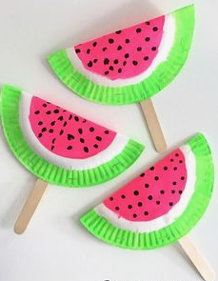

- Paper plate Jelly Fish:
Paint the top/front of a paper plate and allow to dry
Draw a curved line across the middle of the plate and cut along the line carefully to make two jelly fish bodies
Ask mom or dad to help you to make holes in the jellyfish along the curved line with a hole punch
Thread some different coloured threads through the holes you punched (to make the tentacles)
Decorate your jellyfish body with more paint, glitter, colours, stickers, eyes, etc
Hang your jellyfish inside the window and watch them flowing in the breeze
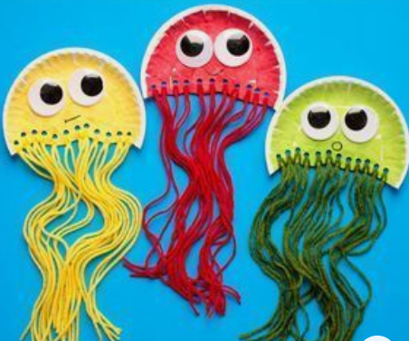
- Art competition: details available on www.drawyourhero.ie

