Hello boys and girls!
I hope you all had a lovely weekend. I bet you are delighted to hear that we are finished with our books and we are going to be doing various activities linked to the theme of ‘Summer’ this week. If you do not have a printer at home, you can use your copybook or an A4 blank sheet.
Please start dusting off your World Book Day outfits as there is a rumour going around that there will be a ‘virtual world book day’ next week
Oral language activity: Ask your child the various questions based on the Summer picture. (The questions are attached to the picture).
Acrostic poem- choose a word linked to summer and create your own poem. I have attached samples but you can choose your own if you would like. Your poem does not need to rhyme.
Lego challenge: Make something linked to summer every day this week using Lego. Create your own water slide, sandcastle, ice cream cone, swimming pool. Can you think of anymore?
SPHE: Read the Sun, Sea and Safety power point.
Create your own Safety poster to highlight how to keep safe at the beach. You can use pictures, bullet points, sentences and so on.
Imagine your poster will be displayed near a beach!
It will need to stand out- be colourful, neat and clear!
Lego Challenge.
DEAR time- drop everything and read!
An A-Z of Summer- look at sheet attached. (You can do this on a sheet/ copybook if you do not have a printer).
PE- Create your own summer obstacle course outside- use skipping ropes, balls, beanbags, hoops- any equipment you have at home that you would like to use. Show it to a member of your family and time them! See who completes it the fastest!
Baking- Have a chat at home and decide what you would like to bake! Rice Krispy buns are always a good option!
Lego Challenge.
Name 5 things challenge card in one minute!
Shopping list- help out at home to make the shopping list for next week.
Music- YouTube ‘Shotgun lyrics’ by George Ezra. Listen to and sing along with the words.
Make up a dance to your favourite song.
Lego Challenge.
Art- Summer Sun Art- see art attached to create your own sun!
Or
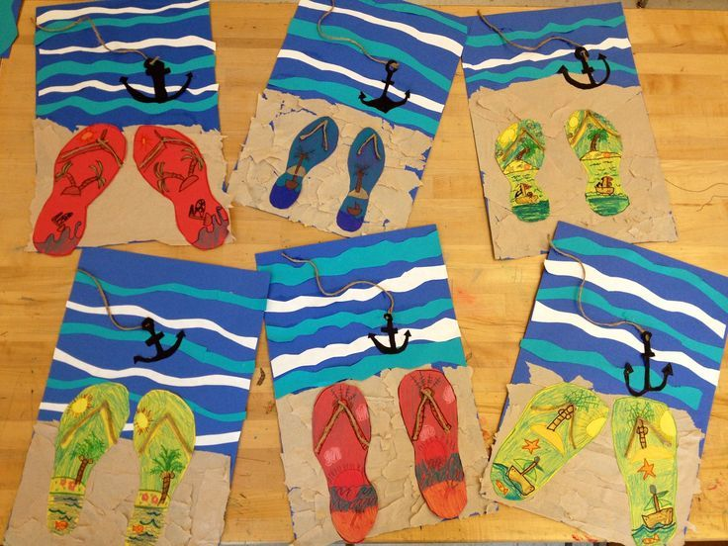 using paint/colours/markers/paper to design the sea, sand and a pair of your flip flops! Add more into the picture if you would like- use your imagination and get creative!
Try a Yoga video on YouTube for 15 minutes.
Active housework- hoovering, mopping, gardening or tidying.
Lego Challenge.
DEAR time- drop everything and read!

