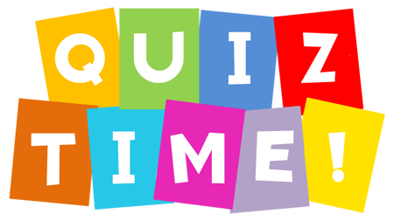
Name:_________________
Date:__________________

- Can you remember the Irish word for window?

- Why was Feena annoyed at the beginning of “At the cinema”?
She was annoyed because_____________________
__________________________________________________________________________________

- I have 10c, 50c, 20c, 5 c. How much do I have altogether?____________________________

- I went to the shop. I had €1. I bought an ice-cream for 75c. How much change did I get?____________

- 145c = €_________

