Senior Infants Work 25th – 29th May
Dear parents,
Here is this week’s school work for senior infants. I hope you are all keeping well and making the most of the time together at home. As always, I can be reached by email at infants.bweengns@gmail.com.
I enjoy seeing all your fabulous pictures of the school work and fun activities that you are doing each week so keep sending them. I am proud of all your hard work so well done everyone!
This week I am going to request that you send me images of two activities during the week!
1. Busy at Maths page 109
2. Skills Book D page 39

Have a great week,
Miss Harrington

New words this week from reader (please cut out green words): may, making, mop, bring, lunch, bowl, fruit, them
Continue to play word bingo, hunt for your new green words in the story
Some games to play while reading:
High Frequency words are generally words that the child can’t form an image of in their minds. This weeks words are : from, use, May, when, what, where, who
- Put the words on the floor scattered about. Your child can throw an object such as two socks rolled up. Can you read the word it lands on?
- See attached time sheet at bottom on document. Can you read all these words in a minute or under? Try to beat your time record daily.

 | Monday | Tuesday | Wednesday | Thursday | Friday
Reading | Reader page 16  New word: May  Reading Eggs – One Lesson | Reader page 17  New words: making, bring  Reading Eggs – One Lesson | Reader page 18  New words: lunch, making, bring  Reading Eggs – One Lesson | Reader page 19  New words: bowl, fruit  Reading Eggs – One Lesson | Reader page 120  New words: them  Reading Eggs – One Lesson
Oral Language | Oral Language based on reader: fruit salad, bananas, apples, pineapple, mangos, strawberries, raspberries, blueberries, pears, plums  Game: Word Tennis with fruits  Spaghetti, colander, grater, extractor fan, cooker head, hob, sharp knife, chopping board, dish  Place 5 counters on some of the above objects on page 20 of reader. Remove if you can name the object.  Theme for this week again is linked to Aistear ‘The Garden Centre’ – In Oral Language we will focus on summer flowers and the lifecycle of a flower  Vocabulary– flower, petal, seed, sprouting seed, seedling, leaf, stem, roots, plant, soil, spade, trowel, rake, tree, garden, grow, pot, flower names (see flower hunt sheet on website)  Listen to the story again ‘The Tiny Seed’ by Eric Carle  https://www.youtube.com/watch?v=ls6wTeT2cKA  If you didn’t get a chance last week - Go on a plant and flower scavenger hunt around the garden, estate or village. (See hunt sheet on website) How many types of flowers can you see?  Can you remember all the parts of a flower? (petals, stem, roots, leaf, seeds)  Do you know what a plant needs to grow? (water, sunlight, soil)  Do you know how a plant grows? Have a look at the powerpoint on the lifecycle of a plant to learn some more. (on website)
Phonics | Phonics :  New sound –wh (what, when, who, where)  Game : Question Quest: Write these words on a piece of paper. Choose a word. Child must ask a question based on illustrations on page 16/17 of At the Beach. Eg What is Denzel drinking?  Rhyming Pairs: cat, bat, gun,bun, fin,tin, log, dog, peg, leg, hug, dug, pen, hen
Spelling | Well boys and girls you are doing so well at your work that we are going to start doing some spellings (I know they are really for First Class but you are all so good I thought we would try some)  Monday : cat, hat  Tuesday : mat, sat  Wednesday: bat, fat  Thursday revise all the words.  The best way to learn spellings is to look, say, cover and write daily.  On Friday write the words down in a list without looking at them if you can. Also see if you can write this sentence. Don’t forget capital letters and a fullstop.  A fat cat sat on a mat.
Phonics | Sounds in Action- page 60 | Sounds in Action- page 61 | Sounds in Action- page 62 | Sounds in Action – page 63 | Sounds in Action – pages 77 and 80
Skills Book | Skills Book D - page 39 | Skills Book D- page 40 | Skills Book D -page 42 | Skills Book D- page 43 | Skills Book D –page 44
Writing | Write Here – page 55 | Write Here – page 56 | Write Here – page 57 | Write Here – Page 58 | Write Here – Page 59
Extra Work | Use your green copy to practice your writing  Use your blue copy and do the corresponding capital letters
Maths | This week we are going to look at money and the coins – 1c, 2c, 5c, 10c and 20c.  Gather as many of the above coins as you can (There’s usually lots of them around the house!)  Get your child to sort the coins in to different sets, e.g. all the 1cents together etc.  Once they are familiar with all the different coins, show them on 5 1cent coins (or 2 2 cents and 1 cent) is the same as 1 5 cent coin – to help them with this concept set up a little shop. Take turns of being the customer/shop keeper.  Below is a little poem to do with money.  I know a little poem.  It isn’t very funny,  It’s about my cent coins,  And how I count my money,  A cent means there’s just one.  Two cent means there’s two,  And we all know that’s one and one.  And to have two cent is really fun.  Five cent means five.  That means two and two and one.  When I have 5 cent.  Off to the shop I run. | Busy at Maths p. 107- Counting the money in the Moneybox  Some questions to ask your child which may assist them;  ‘What coins are in the box?’ (3 2 cent coins)  ‘How much money is in the box in total?’(2+2+2 = 1+1+1+1+1+1 = 6) | Try this maths game and see how much money is in the piggy bank! Have fun  Click; Counting – 1c to 10c – Make sure to click on EU flag on the bottom to select euro currency!  https://www.topmarks.co.uk/money/coins-game  Busy at Maths p. 108- Counting in 1cent  Read price tag on item and colour the correct amount of coins.  Ask your child questions such as:  What price is on the price tag?  How many 1 cent coins are there in the first row?  How many coins must we colour to match the price tag?  Which is the cheapest/dearest food?  What two foods cost a total of 9c? | Busy at Maths p. 109  Similar to yesterday, the correct amount of coins must be coloured to equal that on the price tag.  Ask your child some of the following questions to assist them complete the activity:  What coins are in the row?  How much money do we need to pay for the item?  Which coins would add up to make ___ cent? | Busy at Maths p. 123- Addition of Money  Adding three items together to total ten cent. Use of coins/concrete material may help understanding.  Encourage your child to count on, i.e.  First item is 1 cent, so start at 1, second item is 2 cent so count on 2 which brings you up to 3, final item is 4 cent, so count 4 steps on from 3 which is 7.

Other activities to try:
Gaeilge
This week we will look at Gaeilge vocab relating to ‘The Garden’ – ‘An Gairdín’

See video of the song ‘Cad atá sa ghairdín?’ on website.
Vocab:
gairdín (garden) crann (tree) balla (wall)
bláthanna (flowers) geata (gate) luascán (swing)
See-saw (see-saw) mór (big)

Phrases/Abairtí:
Cad atá sa ghairdín? (What is in the garden?)
Tá ___________ sa ghairdín. ( _________ is in the garden.)

Children can have fun singing along. They can also choose 4 or 6 items and draw them in a ‘BINGO card’. Parents can call irish words one by one and the children can cross the picture out if they have it.
They can also draw a simple ‘gairdín’ (garden) on a blank A4 page. Parents can call out the phrase ‘Cuir __________ (eg: crann) sa ghairdín’. Children then draw that item in the garden. Continue until all items are in the garden. Then ask the child the question: Cad atá sa ghairdín? And encourage them to answer with ‘Tá crann/geata etc sa ghairdín’.

Days of the week/Weather
Each morning in school we always start our day by reciting the days of the week and we fill in our calendar and weather chart so here are some questions to focus on each morning-
-What day is it today? What day was it yesterday? What day will tomorrow be?
-What month/season is it?
-What is the weather like today?
-Cén saghas lae é? (What sort of day is it?) Tá an lá ___________. fliuch(wet), fuar(cold), te (hot), tirim (dry), gaofar (windy), scamallach (cloudy). Tá an ghrian sa spéir. (The sun is out). Tá sé ag cur báistí. (It is raining)
PE
- Join The Body Coach Joe Wicks live every morning at 9am
- ‘Just Dance’ on Youtube has lots of fun dance activities for infants - ‘I Like to Move It’, ‘I’m a Gummy Bear’, ‘Trolls: Can’t Stop the Feeling’, ‘I’m Gonna Catch You’, ‘Shake it Off’, ‘Walking on Sunshine’.
- www.fyffesfitsquad.ie have online lessons daily.
- Why not try some kids yoga on the CosmicKids Yoga channel on youtube
- mollys_mini_movers provides free fun fitness classes for kids aged 3-8 every Wednesday on her Instagram page (10am – 3-5 years , 10.30am – 5-8years, 11:15 – Montessori level)

Aistear/Art
Our theme for Aistear is ‘At the Garden Centre’. Here are some activities around the theme to have some fun with:
- Role Play – Pretend play using whatever equipment is available to you at home eg: spades, trowels, rakes, flowers, seeds, hose, flower pots, watering can, garden gloves, equipment for selling items eg: cash register, money
- Messy Play – Plant some seeds (even the seeds from an apple will do) What tools do you need? – Have the opportunity to ‘garden’ and explore soil and using tools like trowels, rakes etc
- Playdough – Can you make some beautiful summer flowers using your playdough? Can you name the parts of your flower?
- Arts and Crafts – Draw/Paint/Create a picture of summer flowers using whatever arts and crafts materials you would like. Send me your creations- I would love to see

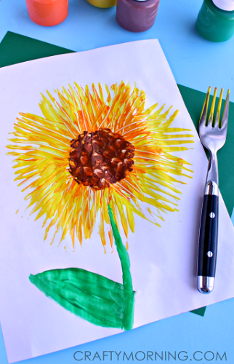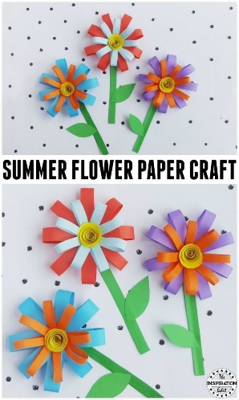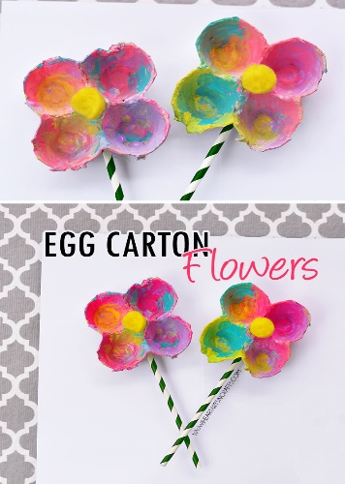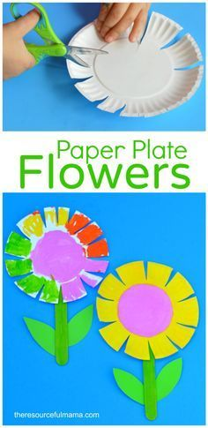
SESE
Lifecycle of a plant – Have a look at the powerpoint on the website and see if you can recall what is needed for a plant to grow. How does a plant grow? What happens?
Cut and Paste Activity on website – Can you order the lifecycle of a plant correctly?

Minibeast Hunt – Explore with me page 65

See how fast you can read all the words below! Can you beat your time tomorrow?
from | use | when | what | where
who | when | who | use | where
from | what | where | use | what
when | from | who | use | from
what | where | who | when | where
use | who | from | when | what
who | from | what | when | where
use | when | from | what | who

