^{2nd class} 2/6/20 - 5/6/20
Hi boys and girls.

I hope you all had a lovely weekend. Keep up the good work. Here is the new timetable for this week. I have included audio clips this week of the Irish reading, these are attached as power point documents.

I have also included videos on the steps on how to do subtraction with renaming again this week. This topic will be covered again in 3rd class so please don’t be worried if you find it difficult. It takes a lot of practice.

Remember if you do not have a printer to print out the activity sheets, you can just write the answers onto a sheet or into a copy. There is no need to rewrite the questions.

I want you to e-mail me back pictures of the following work this week:
Maths book p 138 + 152 to 2ndclassmsh@gmail.com.

Please remember to say your prayers before and after communion.

From 8th June our time table will be a little different. We will be doing some fun activities including my favourite, science experiments. In order to complete these experiments you will need a few household items. So have a look in the presses at home this week and start gathering the items that you will need. Don’t worry if you don’t have all of the items in time for each experiment. All the experiments will be saved on the website and you will be able to complete them at your own pace.

Sealable plastic sandwich bag
Blue food colouring and one other colour.
Permanent marker
Sticky tape
Raisins
Fizzy/sparkling water
Eggs
Salt
White vinegar
Kitchen roll
Bubble wrap(or another type of material: you could use a piece of cloth,towel, cotton wool, a wooly hat)
Skittles
Cooking oil

Important note about Book scheme:
Please start gathering book scheme books and put them into a plastic bag with your name and class on it. These include Wonderland readers Treasure Hunt and GG’s new job and any other library books that belong to the school. A collection date will be given in due course.

Hope you all have a great week.

Ms Heffernan

 | Monday | Tuesday | Wednesday | Thursday | Friday
 |  | Quiz time sheet attached
Bua na Cainte  Theme: |  | Bua na Cainte p 91  An Nuacht  (listen to me reading the sentences and fill in the blanks) | Bua na Cainte p 93  Listen to me read the sentences and write down the answers.  Cheannaigh (bought)  Níor Cheannaigh (didn’t buy) | Bua na Cainte p 95  Listen to me read the words at the top of the page. Say the sentences after me.  Write the correct amount into the boxes. | Spellings and Tables test
Irish library book:  www.cj fallon.ie  Ceim ar cheim  Cairde le Cheile 2 |  |  |  | Lib book p 52  Voice note attached | Lib book p 53  Voice note attached
Irish spellings  Sentences this week |  | ag siopadóireacht  (shopping) | Cheannaigh mé  (I bought) | Níor cheannaigh mé  (I didn’t buy)
Reading |  | A Surprise for Feena p 15+16  (online reader)  Cj fallon.ie  2nd class, English, Wonderland | A Surprise for Feena p 17+ 18  (online reader)  Cj fallon.ie  2nd class, English, Wonderland | A Surprise for Feena p 19+20  (online reader)  Cj fallon.ie  2nd class, English, Wonderland | Small World p 81/82  Read and Write.
Writing |  | Skills book p57 | Skills book p 59 | Skills book p 61
Spellbound |  | P 62 box 1  A B | P 62 box 2  C D | P 62 box 3  P63 E F | P 63  G
Tables Revision |  | +5 | +5 | +5
Maths  Strand:  Number  Subtraction with and without renaming. |  | Busy at maths p 137  If your child finds the extra boxes over the sums confusing they can just stick to way I am demonstrating in the videos.  I have included a video of subtraction rules.  I have included a video on how to do subtraction with and without renaming.  We did cover this topic a little bit before we finished up but it will be covered again in 3rd class so don’t worry if you are finding it difficult. | Busy at Maths p 138 | Busy at Maths p 152 | Busy at Maths p 153
 |  |  |  |  | Art see ideas below

Religion: log onto https://app.growinlove.ie/en/user/dashboard
username trial@growinlove.ie password growinlove
Click on 2nd class book.
Next theme- listen to the stories and sing the songs. You can print some worksheets aswell..
You can light a candle and say a prayer every day.
Prayers before and after communion.
PE: It is very important to get exercise every day. The body coach is doing PE classes on his youtube channel every morning. We also love doing go noodle in school. You can sign up for free. It offers a range of exercises that can be done inside.
Art ideas-
Life cylce of a butterfly activities:
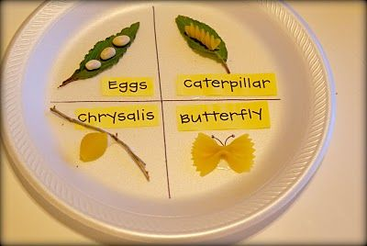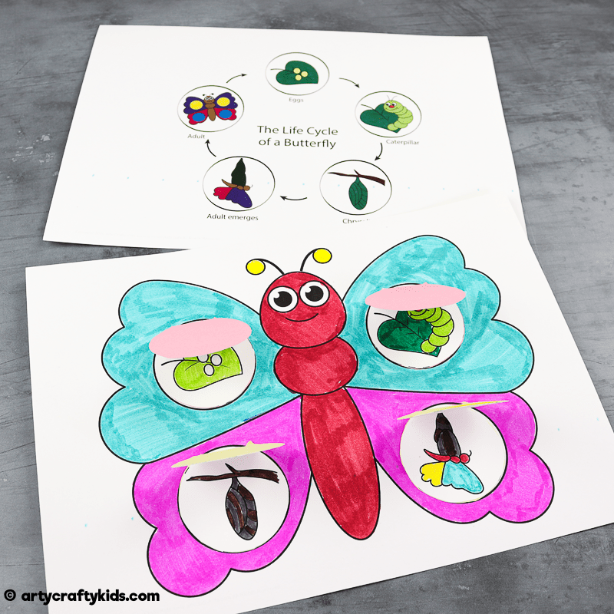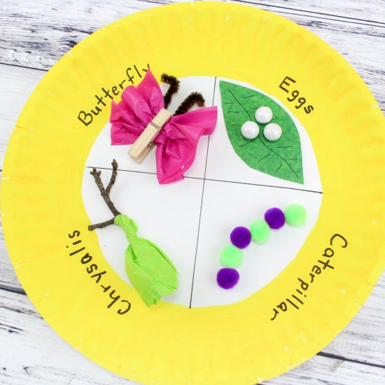

Extra activities if you need them. If you do not get time to complete the extra activities don’t worry.

- Nuacht/News time – Discuss weather, what day it is today, what day was yesterday, what day it will be tomorrow, what month and season we are in, how many days in the month. Take out the calendar and fill in any special occasions coming up – birthdays , Easter ……..
Cén lá atá ann inniu? Inniu an _______. (Days of the week in Irish can be found in bua na cainte)
Cén lá a bhí ann inné? Inné an _______.
Cé lá a bheidh ann amárch? Amárach an____________.
Tá an lá ________ ( weather words can be found in bua na cainte)
- Tables race – write down 15 sums . Set the timer to 1 min and see how many you can complete. If you want more of a challenge reduce your time or increase the number of sums.

