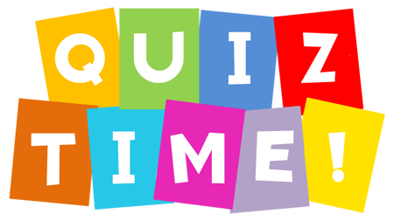
Name:_________________
Date:__________________

- Can you remember the Irish word for sandwich?

- What flavour crisps was Orin eating?
He was eating_____________________
__________________________________________________________________________________

- Which is heavier ¼ kg or ½ kg?____________

- 1 litre = ______ml.

- What does a plant need in order to grow?

_______________________________________.

