Master Your Maths 4 Answers (Week 27) Daily Work and Weekly Test (20/4/2020 – 24/4/2020)
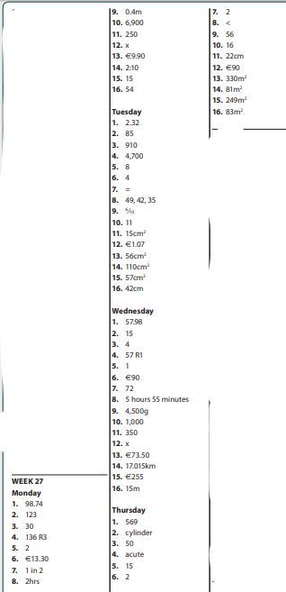

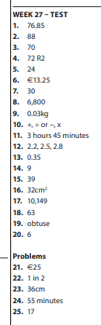

Busy at Maths 4 Answers (Chapter 25 Time)
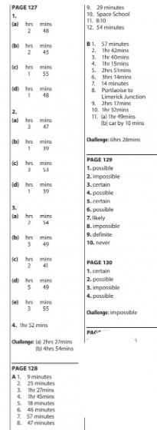

Bun Go Barr P.104 + 105
A | C | E
- Shuigh  - D’fhan  - D’inis  - Bhuail  - Leag  - Mhoilligh  - Ní dhearna | - Liom  - Duit  - Leis  - Uirthi  - Orainn  - Libh  - Dóibh  - Orm | - Bhí  - Tháinig  - D’ith  - Chonaic  - Rug  - Fuair  - Rinne  - Chuala  - Chaith  - Dúirt  - Chuaigh

