2nd class 5/4/20- 8/5/20
Hi boys and girls.
Well done to you all. It looks like you are all working really hard. Keep up the good work. Here is the new timetable for this week.
Just try your best to get as much as you can done. Also if you do not have a printer to print out the activity sheets, you can just write the answers onto a sheet or copy no need to rewrite the questions.

Myself, Aoife and Suzie are really enjoying our walks every day. I hope you are all getting some exercise every day as well. I have included a picture I took on one of our walks this week. Can you spot a particular yellow flower that we learned about in our Small World? Draw this flower on a sheet and write 4 facts that you can remember about it. Once you have written your 4 facts you can check your small world to see if you are correct.

I also want you to create a poster about another type of flower /plant that you might have in your garden or that you have seen on your walks. Include a labelled diagram (petals, stem, leaves, roots) and also include 4 facts about this particular flower /plant. You don’t have to complete this poster all on one day, you can do a bit of the poster every day if you’d prefer.

Please remember to say your prayers before and after communion. I encourage you all to listen in to mass on the Glantane Parish facebook page on Sunday at 11. I have attached new song words also for this online Mass. – We come to you Lord Jesus.

We have chosen the names Mike and Molly for the calves.

Hope you all have a great week.

Ms Heffernan

Reading Eggs
A number of weeks ago we recommended you register with the programme Reading Eggs. Feedback to date is very positive. As the educational benefits are good should the free trial end next week the school is prepared to purchase the programme for the school for a year. However, there is a slight difficulty. The company have informed me that should the school purchase the programme then every parent will have to re-register and commence again. So the plan is to ask you as parents to pay for the programme for your child.Save your proof of purchase. The school will deduct this amount from the book loan cost for the school year 20/21.
Coming soon: A survey on distance learning in the context of Bweeng N.S
 | Monday | Tuesday | Wednesday | Thursday | Friday
Bua na Cainte  Theme: Sa bhaile  food |  | P82  Read food words  Write and read sentences  Ba mhaith liom– I would like…… | P 83  Top part of page  Thug Mamaí ___ dó.  (Mammy gave ___ to him.) | P83  Bottom part of the page  Thug Mamaí ___ di.  (Mammy gave -____ to her) | Spellings test  P84 An Nuacht  New words:  Thug –gave  Tháinig - came
Irish library book:  cj fallon.ie  Ceim ar cheim  Cairde le Cheile 2 |  |  |  |  | P55 Déan ceapaire
Irish spellings  Can be found in bua na cainte p 82/83 |  | ceapaire (sandwich) | Uachtar reoite ice cream | cáis (cheese)
English reading |  | Poem:  Five little flowers (sheet attached)  Read poem. Find the rhyming words.  Draw the five flowers. | Read at Home p 5 Tomatoes (cjfallon.ie)  Answer questions orally | Read at home p 11 the Sweet Tree  (Cjfallon .ie)  Answer questions orally
English writing |  | Go on a word hunt through magazines or books and find any words that have (r blends) similar to page 48 in skills book  Cr, gr, dr, fr, pr, tr, ,br  Write down the ones you find in a copy or on a sheet of paper. | Skills Book p 50  Compound words  Put 6 of the compound words into sentences. | All write Now p 53  Compound words. | Try and write your own poem about flowers.
Spellbound |  | P 54 box 1  P 52 C +D | P 54 box 2  P 53 E+F | P 54 box 3  P 53 G + H
Tables |  |  |  |  | Tables Race game see below
Maths  Capacity  See parent sheet attached |  | Busy at maths p 144 | Busy at maths p 145 | Busy at maths p146 | Busy at maths p 147
Science  Extra science activity attached  Floating flowers experiment |  | Flower poster/project  Flower poster. Draw a flower or plant and write 4 facts about it. |  |  | Art: see ideas below

Religion: log onto https://app.growinlove.ie/en/user/dashboard
username trial@growinlove.ie password growinlove
Click on 2nd class book.
We are on Theme 7 - listen to the stories and sing the songs. You can print some worksheets aswell..
You can light a candle and say a prayer every day.
Prayers before and after communion.

PE: It is very important to get exercise every day. The body coach is doing PE classes on his youtube channel every morning. We also love doing go noodle in school. You can sign up for free. It offers a range of exercises that can be done inside.

Art ideas-
Draw a picture of your garden.
Flower printing if you have paint at home. Using flowers as your paintbrush.
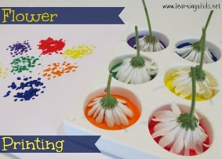

Flower sun catchers using sticky contact paper or else cling film. Make sure you let the flowers dry out fully before you make your sun catcher. Put them between newspaper sheets and put a heavy book on top in order to press them flat. Leave them for a few hours.
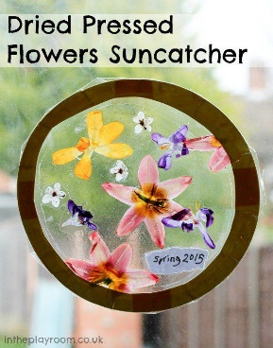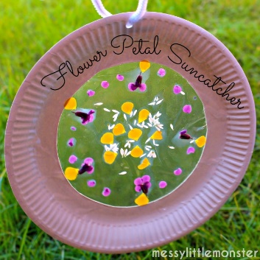
If you do not have cling film or sticky contact paper you could create a dried flower picture. By simply leting them dry out as the instructions tell you above. Then put a bit of prit stick on your plain white sheet. Arrange the flowers on the sheet what ever way you want. If you have a picture frame you could cut the sheet down to size and display it in your home.
Extra activities if you need them. If you do not get time to complete the extra activities don’t worry.
- Science experiment – Floating flowers – see sheet attached (you do not need colour paper, just ordinary plain white paper will do and you can also experiment with different types of paper and see the effects on each one. E.g. news paper
- Nuacht/News time – Discuss weather, what day it is today, what day was yesterday, what day it will be tomorrow, what month and season we are in, how many days in the month. Take out the calendar and fill in any special occasions coming up – birthdays , Easter ……..
Cén lá atá ann inniu? Inniu an _______. (Days of the week in Irish can be found in bua na cainte)
Cén lá a bhí ann inné? Inné an _______.
Cé lá a bheidh ann amárch? Amárach an____________.
Tá an lá ________ ( weather words can be found in bua na cainte)
- Tables race – write down 15 sums . Set the timer to 1 min and see how many you can complete. If you want more of a challenge reduce your time or increase the number of sums.

