Senior Infants Work 15th – 19th June
Dear all,
I hope you are all well. Here is this week’s work for Junior Infants. Again there is a very small amount of book work along with lots of practical fun activities. This week we are having our first ever ‘Active Home Week’ instead of our usual ‘Active Schools Week’. There is an attached document with all the details. It will be lots of fun so I am encouraging as many families as possible to take part.
Also, Friday is World Book Day so the kids are encouraged to dress up as their favourite character from a book and spend some time reading. This week, I am requesting that you send me some images of the kids engaging with Virtual Sports Week and/or dressed up for World Book Day. We will be forming an online gallery for our website. As always these can be sent to me at infants.bweengns@gmail.com.

Have a great week,
Miss Harrington

 | Monday | Tuesday | Wednesday | Thursday | Friday
Reading | Play roll the dice and tick off the word  Skills Book - Make and read the strip book ‘Who is it?’ – page 53 | Play the game roll the dice and write the word  Skills Book - Make and read the strip book  ‘Things We Like’ – page 55 | Play the game roll the dice with two players | Play snakes and ladders game to practice words | Spend some time reading your favourite book for World Book Day.
Oral Language | This week I want you to have some fun playing ‘Word Tennis’. (See the powerpoint on the website)  A category is chosen eg: sports, fruit, boys names, things you would find in a kitchen.  Player A stands opposite Player B. Players must take turns listing an item or object linked to the topic.  If a player repeats a word, stalls or cannot name an item, a point is awarded to the opposite player.
Phonics | Revise initial blends sk, sl, sm, sn, sp, st  Can you read the word lists? Can you think of any other words beginning with these letter blends?  sk sl sm sn sp st  skin skip skid skate slip slug slam slap small smash smart smell snap snack snip snug spin spot spud spit stop step star stem  Now can you find the corresponding page in your pack (Cut and Paste Blends – sk, sl, sm, sn, sp, st) and cut and paste the pictures under the correct letters.
Phonics | Sounds in Action – page 73 | Sounds in Action- page 74 | Sounds in Action- page 75 | Sounds in Action – page 76 | Sounds in Action – page 78
Writing | Writing template in pack – ‘What can you see at the beach?’  Look at the picture. What is happening? Can you write some simple sentences about the picture?  Eg: It is a hot day. The dog is running. The girl is on the rug. Etc.  Write a story called: ‘My time at home from school’.  Use some of the sight words from the list in your pack. Remember, you can glue all of these sheets into your scrapbook
Maths  Trail | Maths Trail Activity Book in your pack – Work through this activity booklet at your own pace during the week!
SESE  (in pack) | My Five Senses Scavenger Hunt  All About Me Activity Sheet

Other activities to try:

Aistear
Our theme for Aistear is linked to Virtual Sports Week - ‘The Sports Shop’. Here are some activities around the theme to have some fun with:
- Role Play – Set up a pretend sports shop with whatever sports equipment/clothing/shoes you may have at home. Eg: jerseys, football boots, balls, rackets, hurleys, swimming items, cash register etc. Encourage children to buy and sell items in the shop.
- Playdough – Can you make some sports related items out of playdough eg: equipment, clothing
- Construction – Can you build a sports shop from lego?
- Arts and Crafts –Draw/Paint/Create your own sports themed art. Some examples might be: Design a jersey (You can even design one for Bweeng NS and the template is on the Virtual Sports Week document), design an Olympic medal, or your own paper plate football/rugbyball. Send me your creations- I would love to see
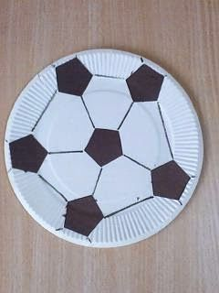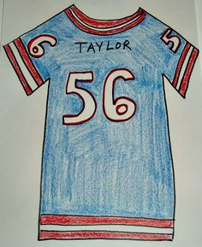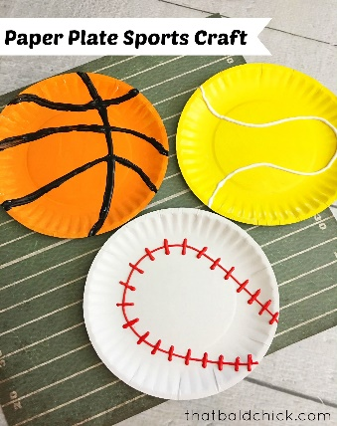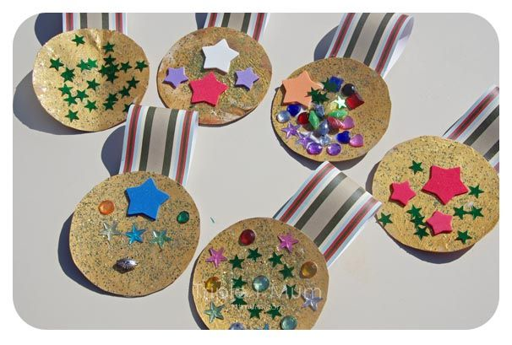

Art
Remember Father’s Day is June 21st so why not create something for Dad or Grandad Here are a few ideas: I have also attached some Father’s Day Certificates on the website for you to print and colour if you like.
