**Long Multiplication**

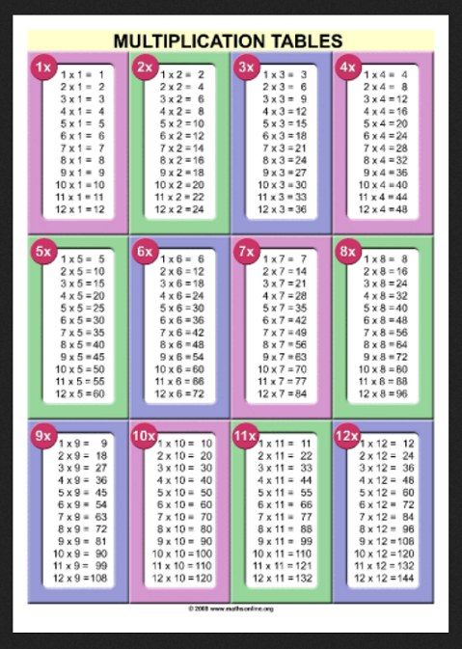

Long multiplication is explained below.





