Easter word wall
Easter | Easter Sunday | Mass
chocolate | eggs | Easter bunny
egg hunt | basket | decorate
holidays | bonnet | April
Spring | chick | lamb

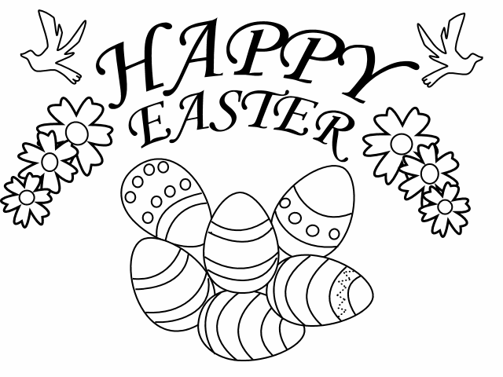
An Cháisc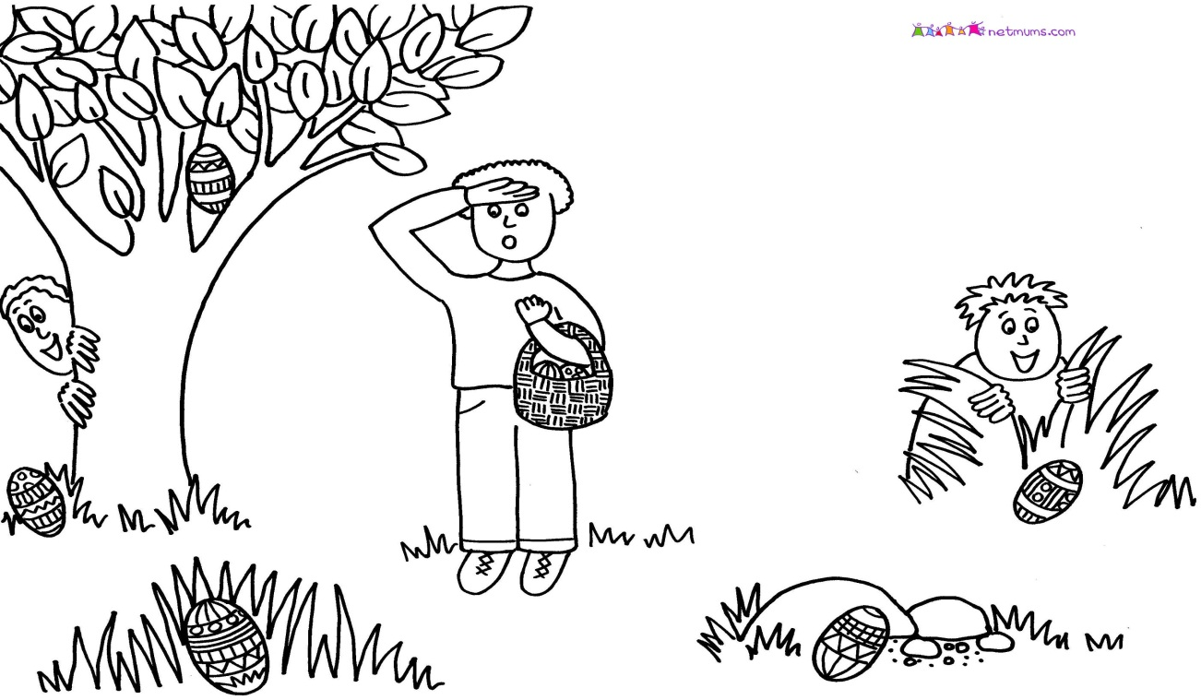
An Cháisc

