Junior Infants Work 15th – 19th June

Dear all,
I hope you are all well. Here is this week’s work for Junior Infants. Again there is a very small amount of book work along with lots of practical fun activities. This week we are having our first ever ‘Active Home Week’ instead of our usual ‘Active Schools Week’. There is an attached document with all the details. It will be lots of fun so I am encouraging as many families as possible to take part.
Also, Friday is World Book Day so the kids are encouraged to dress up as their favourite character from a book and spend some time reading. This week, I am requesting that you send me some images of the kids engaging with Virtual Sports Week and/or dressed up for World Book Day. We will be forming an online gallery for our website. As always these can be sent to me at infants.bweengns@gmail.com.

Have a great week,
Miss Harrington

 | Monday | Tuesday | Wednesday | Thursday | Friday
Reading/Phonics | Just Phonics page 78 – Sound out and write each word  https://www.ictgames.com/mobilePage/helpAHedgehog/index.html  See how many words you can read in 90 seconds. Can you beat your score a second time?  (Click on ‘Phase 2 CVC words’) | Just Phonics page 79- Sound out and write each word  Activity Sheet in pack ‘Cut and Stick’ – Cut out the letters on the side of the page and use the letters to spell the word for each picture! | Just Phonics Half of page 80- Revision – Can you draw something for each letter?  Activity Sheet in Pack ‘I Can Read! Phase 2 Set 3’ – Read the words tag, pot, gap, dig, gas, pig’ and match the picture to the word. | Just Phonics half of page 80- Can you draw something for each letter?  https://www.phonicsplay.co.uk/resources/phase/2/pick-a-picture  Play this online game.  Click on ‘Phase 2’ and ‘Revise all phase 2’. If this is too easy for your child they can try Phase 3.  Username: march20  Password: home | Spend some time reading your favourite book for World Book Day.
Writing | Practice Writing in your yellow writing copy daily
Oral Language | This week I want you to have some fun playing ‘Word Tennis’. (See the powerpoint on the website)  A category is chosen eg: sports, fruit, boys names, things you would find in a kitchen.  Player A stands opposite Player B. Players must take turns listing an item or object linked to the topic.  If a player repeats a word, stalls or cannot name an item, a point is awarded to the opposite player.
Maths | Maths Trail Activity Book in your pack – Work through this activity booklet at your own pace during the week!
SESE | My Five Senses Scavenger Hunt  All About Me Activity Sheet

Other activities to try:

Aistear
Our theme for Aistear is linked to Virtual Sports Week - ‘The Sports Shop’. Here are some activities around the theme to have some fun with:
- Role Play – Set up a pretend sports shop with whatever sports equipment/clothing/shoes you may have at home. Eg: jerseys, football boots, balls, rackets, hurleys, swimming items, cash register etc. Encourage children to buy and sell items in the shop.
- Playdough – Can you make some sports related items out of playdough eg: equipment, clothing
- Construction – Can you build a sports shop from lego?
- Arts and Crafts –Draw/Paint/Create your own sports themed art. Some examples might be: Design a jersey (You can even design one for Bweeng NS and the template is on the Virtual Sports Week document), design an Olympic medal, or your own paper plate football/rugbyball. Send me your creations- I would love to see
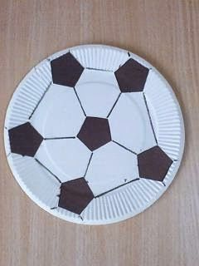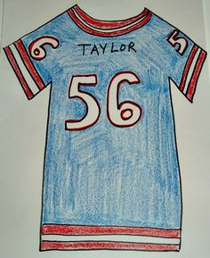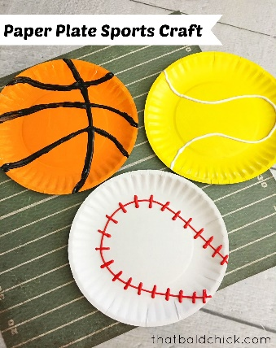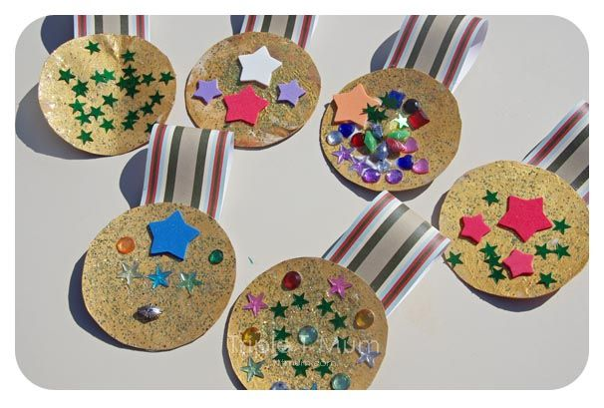

Art
Remember Father’s Day is June 21st so why not create something for Dad or Grandad Here are a few ideas: I have also attached some Father’s Day Certificates on the website for you to print and colour if you like.
