Senior Infants Work 2nd – 5th June
I hope you all had a lovely bank holiday weekend and enjoyed the sunshine. Here is this week’s school work for senior infants. I have not assigned work for Monday as it is a bank holiday but feel free to get a start on the weeks work if it suits you better to do so. As always, I can be reached by email at infants.bweengns@gmail.com.
As we are nearing the end of the school year I’m kindly asking you all to gather any book scheme books that you may have at home and put them into a plastic bag with your child’s name on the bag. Mrs. Sheehy or Ms. Buckley will be in touch shortly to arrange collection. Books that Senior Infants may have at home include:
- Globby Helps Out (reader – CJ Fallon)
- The Beach House (reader – CJ Fallon)
- Any small library books – PM readers, red rocket readers or Wonderland readers
I enjoy seeing all your fabulous pictures of the school work and fun activities that you are doing each week so keep sending them. I am proud of all your hard work so well done everyone!
This week I am going to request that you send me images of certain activities during the week!
1. Skills Book page 45
2. Busy at Maths page 113

New words this week from reader (please cut out green words): each, tray, mugs, slips, worry, our, train
Continue to play word bingo, hunt for your new green words in the story
Some games to play while reading:
- Put the words on the floor scattered about. Your child can throw an object such as two socks rolled up. Can you read the word it lands on?

 | Monday | Tuesday | Wednesday | Thursday | Friday
Reading |  | Reader pages 21 and 22  New words: each, tray, mugs, slips  Reading Eggs – One Lesson | Reader pages 23 and 24  New words: worry, our turn  Reading Eggs – One Lesson | Readers Theatre – See attached  Reading Eggs – One Lesson | Check out how well you know the words from ‘The Beach House’  Reading Eggs – One Lesson
Oral Language | Oral Language based on reader:  What did you learn about Feena’s character from reading this story? What words would you use to describe Feena?  Reread the story and discuss the following: Who is the main character in the story? Look and talk about the pictures and ask where the story takes place(setting). Read on and then ask or talk about the problem. Continue to the end and talk about the resolution.  Theme for this week again is linked to Aistear ‘The Garden Centre’ – In Oral Language we will focus on the theme minibeasts.  What is a minibeast?  - A minibeast is a small animal or ‘creepy crawly’.  - Minibeasts have no backbone.  - Minibeasts do not have a skeleton on the inside.  - Some minibeasts have a hard shell to live in.  - Minibeasts can be found on land, water and air.  - There are a lot of different kinds of minibeasts. Can you name any?  Vocabulary – spider, slug, beetle, butterfly, woodlouse, daddy-long-legs, wasp, ladybird, snail, dragonfly, ant, worm, fly, bee, caterpillar, millipede, earwig,  Read to the powerpoint story ‘The Cautious Caterpillar’ (on website).  Chat about the story and answer the following questions orally-  - What kind of creature is cody at the beginning of the story?  - How many legs does Cody have when she is a caterpillar?  - Can you name two creatures that Cody speaks to about becoming a caterpillar?  - When Cody is still a caterpillar, what does she say about the idea of flying?  - Why doesn’t Cody want to become a butterfly?  - What does the grasshopper say having six legs is plenty for?  - What does Cody finally do that is very brave?  - Why does Cody tell the caterpillar not to worry at the end of the story?  Some fun activities linked to the story (on website) – Make Cody’s butterfly cupcake recipe, play the ‘What am I?’ interactive powerpoint game, Cody the caterpillar’s minibeast count.
Phonics | Revise wh sound – Can you read: whip, when, wheel, whisper, which, whisker, whisk, where, who  New sounds: Putting two letters together:  cr: Find these words in The Beach House: cream, crackers, cross  fr: Find fr words in your reader  Do the same for tr, dr, br and gr.
Spelling | Tuesday : mug, dug jug  Wednesday: bug, hug, rug  Thursday revise all the words  The best way to learn spellings is to look, say, cover and write daily.  On Friday write the words down in a list without looking at them if you can. Also see if you can write this sentence. Don’t forget capital letters and a full stop.  I see a bug on a rug.
Phonics |  | Sounds in Action- page 64 | Sounds in Action- page 65 | Sounds in Action – page 66 | Sounds in Action – page 67
Skills Book |  | Skills Book D- page 45 | Skills Book D -page 46 | Skills Book D- page 47 | Skills Book D –page 48
Writing |  | Write Here – page 60 | Write Here – page 61 | Write Here – Page 62 | Write Here – Page 63
Extra Work | Use your green copy to practice your writing  Use your blue copy and do the corresponding capital letters
Maths |  | Before/after/between  Practice counting forward and backwards 1-20 – ask your child questions such as:  What number comes before 7?  What number is after 13?  What number is between 2 and 4?  Busy at Maths p. 112  Fill in what number is between. | Busy at Maths p. 113- Fill in number before/after  Practice counting forwards and backwards to 20 before completing activity.  Fill in what number is before and after. | Busy at Maths p. 117 - Holds more/less than:  What container holds the most/least – colour the container that holds the most yellow. Colour the container that holds the least pink. | Busy at Maths p. 118 – How many cupfuls?  Find a bowl, teapot/ jug, bottle and a pot.  First get your child to guess/estimate how many cups they think it would take to fill the bowl, teapot/jug, bottle and pot.  Then use cups of water/ sand /dried rice/pasta etc. to measure how many cups the item will hold.

Other activities to try:
Gaeilge
This week we will look at Gaeilge vocab relating to ‘The Garden’ – ‘An Gairdín’

See video of the song ‘Cad atá sa ghairdín?’ on website.
Vocab:
gairdín (garden) crann (tree) balla (wall)
bláthanna (flowers) geata (gate) luascán (swing)
See-saw (see-saw) mór (big)

Phrases/Abairtí:
Cad atá sa ghairdín? (What is in the garden?)
Tá ___________ sa ghairdín. ( _________ is in the garden.)

Children can have fun singing along. They can also choose 4 or 6 items and draw them in a ‘BINGO card’. Parents can call irish words one by one and the children can cross the picture out if they have it.
They can also draw a simple ‘gairdín’ (garden) on a blank A4 page. Parents can call out the phrase ‘Cuir __________ (eg: crann) sa ghairdín’. Children then draw that item in the garden. Continue until all items are in the garden. Then ask the child the question: Cad atá sa ghairdín? And encourage them to answer with ‘Tá crann/geata etc sa ghairdín’.

Days of the week/Weather
Each morning in school we always start our day by reciting the days of the week and we fill in our calendar and weather chart so here are some questions to focus on each morning-
-What day is it today? What day was it yesterday? What day will tomorrow be?
-What month/season is it?
-What is the weather like today?
-Cén saghas lae é? (What sort of day is it?) Tá an lá ___________. fliuch(wet), fuar(cold), te (hot), tirim (dry), gaofar (windy), scamallach (cloudy). Tá an ghrian sa spéir. (The sun is out). Tá sé ag cur báistí. (It is raining)
PE
- Join The Body Coach Joe Wicks live every morning at 9am
- ‘Just Dance’ on Youtube has lots of fun dance activities for infants - ‘I Like to Move It’, ‘I’m a Gummy Bear’, ‘Trolls: Can’t Stop the Feeling’, ‘I’m Gonna Catch You’, ‘Shake it Off’, ‘Walking on Sunshine’.
- www.fyffesfitsquad.ie have online lessons daily.
- Why not try some kids yoga on the CosmicKids Yoga channel on youtube
- mollys_mini_movers provides free fun fitness classes for kids aged 3-8 every Wednesday on her Instagram page (10am – 3-5 years , 10.30am – 5-8years, 11:15 – Montessori level
Aistear/Art
Our theme for Aistear is ‘At the Garden Centre’. Here are some activities around the theme to have some fun with:
- Role Play – Pretend play using whatever equipment is available to you at home eg: spades, trowels, rakes, flowers, seeds, hose, flower pots, watering can, garden gloves, equipment for selling items eg: cash register, money
- Messy Play – Plant some seeds (even the seeds from an apple will do) What tools do you need? – Have the opportunity to ‘garden’ and explore soil and using tools like trowels, rakes etc
- Playdough – Can you make some beautiful summer flowers using your playdough? Can you name the parts of your flower?
- Arts and Crafts – Draw/Paint/Create a picture of summer flowers using whatever arts and crafts materials you would like. Send me your creations- I would love to see

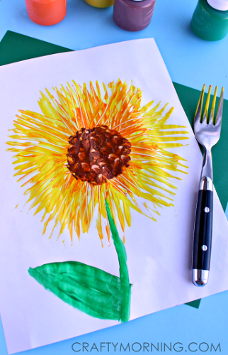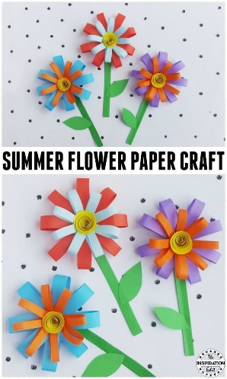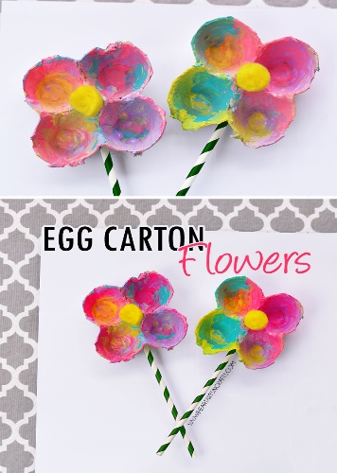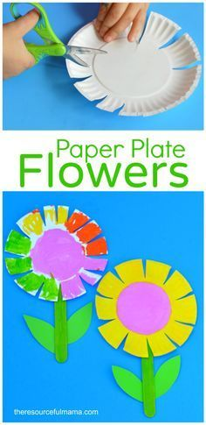
SESE
See activities on ‘minibeasts’ in Oral Language section above.

