Junior Infants Work 8th – 12th June
Dear all,
I hope you all had a lovely weekend. Here is this week’s school work for junior infants. There is a mix between book work and more practical fun activities that are in the pack that you all collected on Friday. As always, I can be reached by email at infants.bweengns@gmail.com. I enjoy seeing all your fabulous pictures of the school work and fun activities that you are doing each week so keep sending them. I am proud of all your hard work so well done everyone!
I just want to make ye aware too that Mrs. Sheehy has sent everyone an email about a new administrative system called Aladdin Connect that we intend to implement this week. It will enable us to send the end of year reports in a manner that is GDPR compliant.
Also, next week we hope to have a ‘virtual world book day’ so start getting your costumes ready to dress up as a character from your favourite book. We also intend to have a ‘virtual sports day’ next week so plenty fun in store for the whole family.
This week I am going to request that you send me images of certain activities during the week!
1. ‘Maths All Around Us, Maths in My Home’ – some or all of the activities can be sent.
2. Just Phonics page 74

Have a great week,
Miss Harrington

Note :
Cork County Council Library and Arts Service is compiling an archive of this unusual era so that a record of our experiences will be available for future generations.

If any of your pupils or teachers is interested in sharing a story, poem or photo that encapsulates 2020, the closure of schools and the lockdown of our country during the COVID-19 crisis and what it means to them they can send it to localstudieslibrary@corkcoco.ie by Monday June 15th.

There are no prizes but the submitted pieces will be stored in an archive in the Local Studies Department of Cork County Library and will hopefully be a valuable resource for future historians when they study this time in history.

 | Monday | Tuesday | Wednesday | Thursday | Friday
Reading/Phonics | Just Phonics page 72 – Revision of middles sounds a,e,i,o,u,  Play snakes and ladders game to revise all your words | Just Phonics page 73- Revision of middle sounds  Initial Sound Cut and Paste Activity (Do this over 2 days)  Cut out all the letters from a-z and all the pictures that go with it.  Can you match the letters to the correct picture? You may like to paste them to a page or card. | Just Phonics page 74- Revision – Write the missing letter  Initial Sound Cut and Paste Activity.  Cut out all the letters from a-z and all the pictures that go with it.  Can you match the letters to the correct picture.  You may like to paste them to a page or card. | Just Phonics page 75- Revision – Write the missing letter  https://new.phonicsplay.co.uk/resources/phase/2/dragons-den  Play this online game.  Click on ‘Phase 2’ and ‘Revise all phase 2’. If this is too easy for your child they can try Phase 3.  Username: march20  Password: home | Play snakes and ladders game to revise all your words  https://www.ictgames.com/mobilePage/helpAHedgehog/index.html  See how many words you can read in 90 seconds. Can you beat your score a second time?  (Click on ‘Phase 2 CVC words’)
Writing | Practice Writing in your yellow writing copy (This was sent home with books earlier in the year but we do not have it started yet)  Children can work away through this at their own pace - one page a day is good.
Skills Book | Skills Book page 64
Oral Language | Use the What Am I cards (on website)  Theme for this week again is linked to Aistear ‘The Garden Centre’ – In Oral Language we will focus on the theme minibeasts.  What can you remember about minibeasts from last week?  - A minibeast is a small animal or ‘creepy crawly’.  - Minibeasts have no backbone.  - Minibeasts do not have a skeleton on the inside.  - Some minibeasts have a hard shell to live in.  - Minibeasts can be found on land, water and air.  - There are a lot of different kinds of minibeasts. Can you name any?  Vocab–spider, slug, beetle, butterfly, woodlouse, daddy-long-legs, wasp, ladybird, snail, dragonfly, ant, worm, fly, bee, caterpillar, millipede, earwig,  Re-read to the powerpoint story ‘The Cautious Caterpillar’ (on website).  Some fun activities linked to the story (in pack) –  1. ‘Minibeast Hunt’. How many minibeasts can you see around the garden/estate?  2. ‘Minibeasts Sorting Activity’ – Can you cut, sort and paste the minibeasts into two categories? Minibeasts with legs/Minibeasts with no legs  3. Design your own butterfly
Maths | This week you will not have any Maths activities in your workbooks. All the activities are in your pack.  1. The Cautious Caterpillar Addition to 10 Colour by number  2. Minibeasts Block Diagram (Look at all the minibeasts at the top of the page – Count how many bees, ladybirds etc there are and colour the corresponding number of boxes on the bottom of the sheet.  3. ‘Maths All Around Us, Maths in My Home’ - Over the course of the week can you complete all these maths activities around the house?  You will have lots of fun

Other activities to try:
Days of the week/Weather
-What day is it today? What day was it yesterday? What day will tomorrow be?
-What month/season is it?
-What is the weather like today?
-Cén saghas lae é? (What sort of day is it?) Tá an lá ___________. fliuch(wet), fuar(cold), te (hot), tirim (dry), gaofar (windy), scamallach (cloudy). Tá an ghrian sa spéir. (The sun is out). Tá sé ag cur báistí. (It is raining)
PE
- Join The Body Coach Joe Wicks live every morning at 9am
- ‘Just Dance’ on Youtube has lots of fun dance activities for infants - ‘I Like to Move It’, ‘I’m a Gummy Bear’, ‘Trolls: Can’t Stop the Feeling’, ‘I’m Gonna Catch You’, ‘Shake it Off’, ‘Walking on Sunshine’.
- www.fyffesfitsquad.ie have online lessons daily.
- Why not try some kids yoga on the CosmicKids Yoga channel on youtube
- mollys_mini_movers provides free fun fitness classes for kids aged 3-8 every Wednesday on her Instagram page (10am – 3-5 years , 10.30am – 5-8years, 11:15 – Montessori level
Aistear/Art
Our theme for Aistear is ‘The Garden Centre/Minibeasts’. Here are some activities around the theme to have some fun with:
- Role Play – Pretend play using whatever equipment is available to you at home eg: spades, trowels, rakes, flowers, seeds, hose, flower pots, watering can, garden gloves, equipment for selling items eg: cash register, money
- Messy Play – Plant some seeds (even the seeds from an apple will do) What tools do you need? – Have the opportunity to ‘garden’ and explore soil and using tools like trowels, rakes etc
- Playdough – Can you make some minibeasts using your playdough?
- Arts and Crafts – Draw/Paint/Create a picture of minibeasts using whatever arts and crafts materials you would like. Here are some idease: toilet rolls bugs, paper plate minibeasts, printing minibeasts. Send me your creations- I would love to see
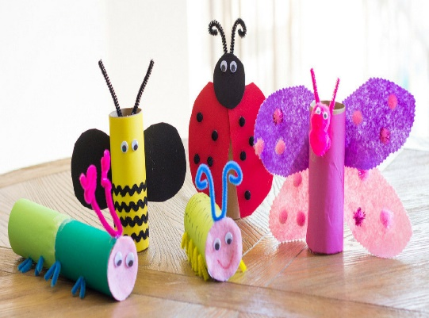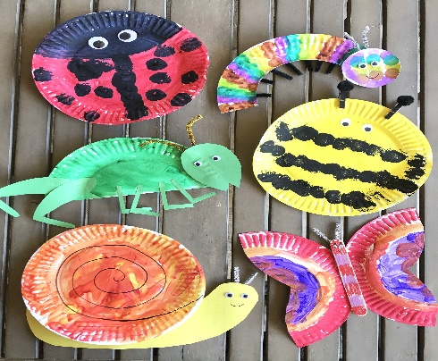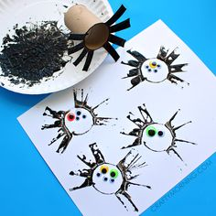
SESE - See activities on ‘minibeasts’ in Oral Language section above.

