HOPPY’S BUSY DAY

Hoppy took one look at the calendar and hopped out of bed. “Oh, my!” he cried. “I almost overslept. It’s only one more day until Easter.”
Hoppy and his friend Bouncy got to work. While the eggs boiled, they picked out colours. Bouncy wanted orange, purple, and red. “I want green and yellow,” said Hoppy. “and stripes.”
They coloured patterns on the eggs with wax crayons and then put them into the coloured dye. They were beautiful.
“The children will love these!” said Hoppy.
Bouncy and Hoppy knew where all the children lived. They got up early Easter morning and hid all the eggs while the children slept. Hoppy got very excited thinking about how much fun the children would have looking for the eggs.
He was very tired when he got back home. He went to bed for a long nap. “Just don’t sleep so long this time,” said Bouncy.
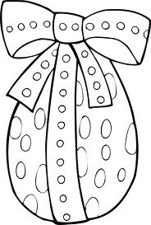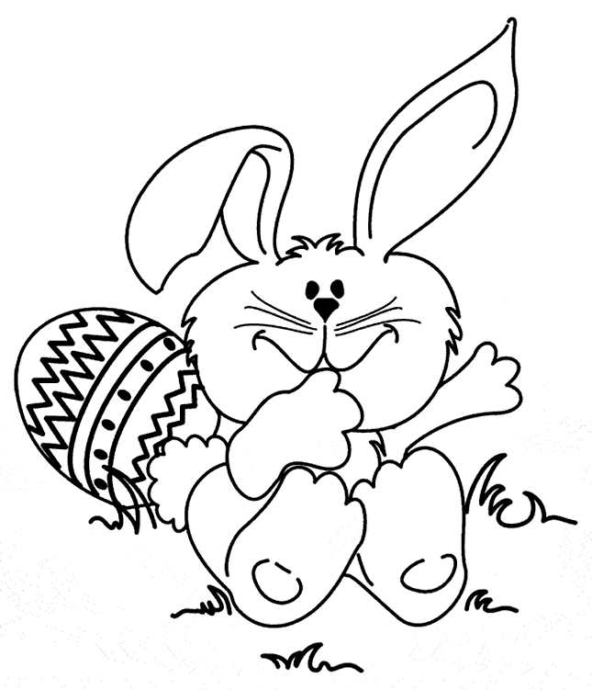

Name _______________________ Date _____________

Choose the best answer to the questions below.
1. What colours does Bouncy like?
a. green and yellow
b. orange, purple and red
c. stripes
d. gold and silver

2. How do they make patterns on the eggs?
a. with wax crayons
b. with dye
c. with paint
d. with boiling water

3. How does Hoppy feel on Easter?
a. sad
b. busy
c. excited
d. disappointed

4. What do you like best about Easter? Why?
____________________________________________________
____________________________________________________
____________________________________________________
____________________________________________________
__________________________________________________________________________________________________________________________________________________________________________________________________________________________________________________________________________________________________________________________________________________________________

