Master Your Maths 6 Answers (Weeks 23-26) Daily Work and Weekly Tests

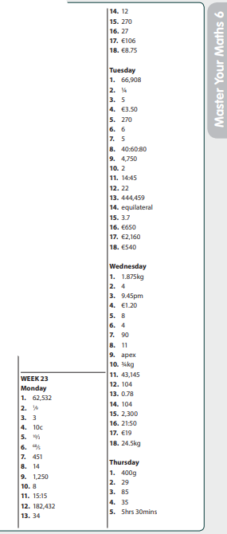

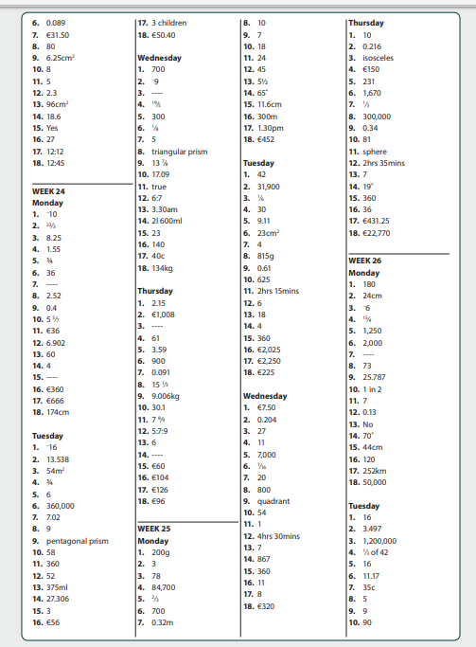

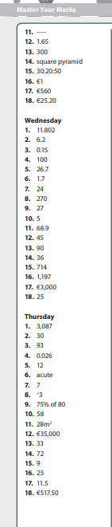

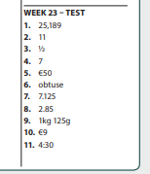

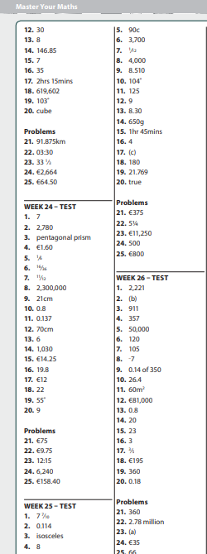

Busy at Maths Answers (6th Class)

PAGE 162  1.  (a) B  (b) C  (c) E  (d) E  (e) A  (f) D  (g) A  (h) C  (i) A  Challenge: 6,600 tones | PAGE 163  1.  (a) 1·65kg  (b) 1·8kg  (c) 2·37kg  (d) 5·075kg  (e) 3·005kg  2.  (a) 4·45kg  (b) 0·445kg  (c) 0·045kg  (d) 0·005kg  (e) 0·7kg  3.  (a) 3,625g  (b) 5,700g  (c) 1,085g  (d) 2,060g  4.  (a) 3,250g  (b) 6,700g  (c) 2·030g  (d) 3,375g  5.  (a) 1,47t  (b) 2·26t  (c) 1·7t  (d) 3·025t  6.  (a) 0·77t  (b) 0·095t  (c) 0·008t  (d) 0·3t  7.  (a) 1·84t  (b) 5·3t  (c) 6·09t  (d) 3·008t  8.  (a) 5·9t  (b) 3·75t  (c) 6·6t  (d) 4·57t  9.  (a) 3/4kg  (b) 3/5kg  (c) 3/8kg  (d) 9/10kg  10.  (a) 7/10t  (b) 2/5t  (c) 13/20t  (d) 9/25t  11.  (a) 3/500t  (b) 1/20t  (c) 13/20t  (d) 3/20t  12.  (a) 51/100t  (b) 7/8t  (c) 7/40t  (d) 3/40t  Challenge: (a) 3·6t  (b) 3 3/5t | PAGE 164  1.  (a) 39·496kg  (b) 123·352kg  (c) 316·26kg  (d) 70·1384kg  (e) 307·36kg  2.  (a) 0·528t  (b) 0·385t  (c) 0·276t  (d) 0·163t  (e) 2·87t  3.  (a) 53·958kg  (b) 33·516kg  (c) 462·944kg  (d) 2·699kg  (e) 4·765kg  (f) 0·246t | PAGE 165  1.  (a) €2·50  (b) €16·50  (c) €10·70  (d) €4·80  (e) €5·40  (f) €7·80  2.  A €19·02;  B €17·69;  C €15·59;  D €10·19;  E €29·73  4.  (a) 200g  (b) 1500g  (c) 800g  (d) 2100g  (e) 1,200g  (f) 3,500g  (g) 8,250g  (h) 13,500g  (i) 8,800g | PAGE 167  1. €50  2.  (a) €45  (b) €5  3.  (a) 3,264g  (b) 3·264kg  4. 15·504kg  5. €78·66  6. 86,400g  7. 162kg  8. 720  9.  (a) 9·72 tonnes  (b) €938·25  10.  (a) 2,240kg  (b) 2,250·4l  Challenge: 16·56 tonnes

Bun Go Barr
P101 D  - Lón  - Sóinseáil  - Teilifís  - Obair bhaile  - Leabhar  - Airgead | P.101 F  - Ag caint  - Ag scríobh  - Ag gáire  - Ag rith | P.102 I  - Tógfaidh  - Ní thógfaidh  - Ceannóidh  - Ní Cheannóidh  - Ólfaidh  - Ní Ólfaidh  - Ní bhaileoidh  - Baileoidh  - Cuirfidh  - Ní Chuirfidh  - Fanfaidh  - Ní Fhanfaidh

