“Virtual Sports Week”: 15th – 19th June
Dear Parents and children,
At this time of the year, we would normally be preparing for our Traditional Sports Day. We want to make sure your children enjoy their last few weeks and are asking all families to jump on board with our idea of a ‘Virtual Sports Week’ from the 15th to the 19th of June.
Here is a step by step guide for everyone:
- Below you will see ‘Our Sports Day Planner’. Here, we are allowing the children, along with you, the parents, to choose your own events for the week. You can change the names of the Days of the Week if you like. Your children have fantastic imaginations and will come up with different games and events. Be prepared to be dragged in to take part!!
- Sample activities your children could do from Monday-Thursday may include:
Create your own obstacle course and race/compete against family members | Create your own family Tic Toc dance | Musical Chairs or Cushions | Try some Yoga – Follow a ‘Cosmic Kids’ routine on youtube | Penalty Shoot-Out
Skipathon | Design your very own hopscotch | Plank Challenge – Can you hold a plank for 30 seconds | How many kilometres can you complete as a family? | Who can jump the furthest?
Take the dog for a walk | How many burpees can you do in 30 seconds? | Hand-pass Challenge | Go-Noodle | Keepy-Uppies Challenge
Target Practice with wall markings | Dice Workout – Assign different activites to each number 1-6 eg: jumping jacks, bunny hops. Throw the dice and do corresponding activity that number of times. | Make up a dance to your favourite song | Play Simon Says with your family | Active Housework (hoovering, mopping, gardening, tidying)
Have a water fight | Crossbar Challenge | Go for a cycle | Complete an Operation Transformation 10@10  https://rtejr.rte.ie/10at10/ | Go for a walk and see if you can find something that begins with each letter of the alphabet
Play balloon volleyball | Count how many star jumps you can do in 1 minute | Throw and catch a ball to yourself 50 times | Plat Tag/Catch | Go for a family walk

Our Sports Week Planner

Day: | Events: | Equipment  Needed:
Magic
Monday
Twistable
Tuesday
Wacky Wednesday
Trampoline
Thursday
Fun-Filled
Friday

Virtual Traditional Sports Day - Friday
- Shopping List – As Friday will be our Traditional Sports Day, it is important to plan ahead and make your shopping list of what you will need early in the week. Preparation is key I have attached a ‘sample’ shopping list for you to use. All these additional touches will make it extra special for the children. Having a little speaker or phone to play their favourite music will also add to the atmosphere for their ‘Virtual Sports Day’. A readymade Spotify playlist you can use is ‘sportsday’ by Éanna Casey.
My ‘Sample’ Shopping List for School Sports Day 2020
- Block of ice-cream and wafers
- 2 packs of jelly snakes
- Multi-pack of popcorn
- Strawberries and dipping chocolate
- Mi-Wadi
- Blowing Bubbles
- Water Pistols
- Party Bags
- Paper/Plastic Cups

- Friday will be the main day for our “Virtual Traditional Sports Day”. There are lots of games, races and traditions attached to school sports day. Games such as the egg and spoon race, the sack race and the 3-legged race are all very much the core of school sports days in Ireland. Let’s revisit them in a virtual setting.
- Below you will see some of these traditional sports day activities explained. Your child can pick and choose as many as they like.
- It would be great to see the whole family get involved and make it as fun as we can for all the children. If Friday does not suit you, why not arrange it for another day or at the weekend. If you take some pictures or videos you can send them to Ms. Harrington (infants.bweengns@gmail.com) . We are hoping to put together a little collection of pictures to represent Bweeng National School Sport’s Day 2020 for our school website. Thank you in advance.

Activity 1: Egg and Spoon/Spud and Spoon Race
Each pupil gets a spoon and an egg(hardboiled) or potato. Each team must carry their egg on their spoon from the starting line to a turnaround point and back again. Then, the egg is passed off to a teammate who takes their turn. If the egg is dropped, the pupil must stop and retrieve it.
Activity 2: Sack Race
Each pupil puts both legs into sack and hops around a cone, or some marked point, and back, tagging the next person in line. Then, the next p upil in line gets into the sack and repeats the once-around the cone course. The pupil or team to the finish line wins.
Activity 3: Through the Gate (Kicking) (Junior classes)
Arrange pupils in pairs with one ball per pair. Each pupil stands on a spot facing their partner who is also standing on a spot ten metres away. Set up a gate between each pair using two cones. Child A attempts to kick the ball to child B through the gate. One point is awarded for each child that successfully kicks the ball through the gate. Single pupils could play the game off a wall. Increase the distance to increase difficulty.
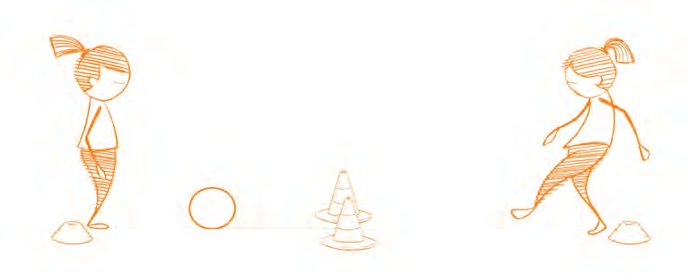

Activity 4: Kick to Score(Kicking) (Middle-Higher Classes)
Draw or stick target areas at various heights on a wall. Points should be placed in the centre of each target from 1-5. Children are given a score to achieve eg: ten. Children must hit the targets on the wall to achieve that number. Alternatively, highest score out of five or ten kicks wins.
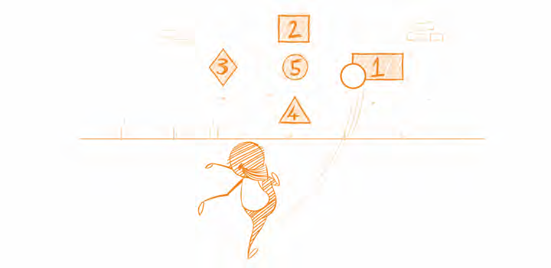

Activity 5: Open-air Twister
Everyone’s favourite physical board game brought to the outdoors. There are a number of phone and table apps to embellish the pupils’ experience eg: ‘Twister Spinner’. The app can replace the twister clock or spinner.
Activity 6: Queen-i-o
A pupil is picked to be the ‘Queenie’, that person turns their back to everyone else. The ‘Queenie’ then throws a ball over their shoulder and one of the other pupils needs to catch it or pick it up. Everyone, except the ‘Queenie’ puts their hands behind their backs so that the ‘Queenie’ does not know who has the ball. The ‘Queenie’ then turns around and everyone shouts:
Queenie, Coko, who’s got the ballio?
The ‘Queenie’ has to guess who has the ball through a process of elimination. If the pupil with the ball is the last one to be picked, that person becomes the new ‘Queenie’. The pupil must admit to having the ball or will automatically be ‘out’. The pupil who is the ‘Queenie’ is not allowed to look when throwing the ball or he/she will be ‘out’.
Activity 7: Soaky Sponges/Water Relay
You will need 2 buckets, water and a sponge (or plastic glass will work) per player.
Fill one bucket up with water and place the other bucket 10 metres away. How much water can you transport to the empty bucket using your sponge (or plastic glass) in 3 minutes? Measure the buckets after 3 minutes to see who has transported more water. (How will you keep the water in the sponge while you transport it?)
Activity 8: Traffic Lights
Invite children to find a space in a large open playing area where they are not in contact with anyone else. On a signal, children move around the playing area in response to the following commands. (You could also turn it into a game of moving statues)
- Red: Stop
- Amber: Walk
- Green: Run

Activity 9: Rock, Paper, Scissors Tag
Arrange children in pairs, standing one metre apart and facing each other. All pairs line up along a centre line with a safety point (cone) 20 metres away. Each pair begins by performing a rock-paper-scissors routine. A rock is a closed fist, paper is a flat hand, and scissors are the index and middle fingers in a cutting position. Paper always covers rock, rock breaks scissors and scissors cuts paper. To determine a winner, count to three and form a rock, paper, or scissors. The winning child then chases thei partner toward the safety cone, attempting to tag them before they are safe. Line up again and repeat the activity.
Activity 10: Sock Challenge Race (run without shoes)
Each player needs 8 socks each. Place a cone/marker at a start line and another cone/marker 10 metres away. Place all your socks in a pile at the marker 10 metres away. On a start signal, each player runs as fast as they can to their pile of socks, takes one, brings it back to the start cone, sits on the ground and puts the sock on. Repeat this until you are wearing all your socks. The first person with all their socks on is the winner. (Note: you are only allowed to bring back one sock at a time).

Other ideas: Wheelbarrow race, piggy back races, three-legged races, relay races

Design a jersey
Design a new jersey for Bweeng N.S.
