^{rfr5nd} class 25/5/20 -29/5/20
Hi boys and girls.
I hope you all had a lovely weekend. Keep up the good work. Here is the new timetable for this week. I have included audio clips this week of the Irish reading, these are attached as powerpoint documents.

I have also included a video of a maths topic that we will be covering next week. Subtraction with renaming. We covered a small bit of this topic before we finished up in school. This topic will be covered again next week and it will also be covered again in 3rd class so please don’t be worried if you find it difficult. It takes a lot of practice.

Remember if you do not have a printer to print out the activity sheets, you can just write the answers onto a sheet or into a copy. There is no need to rewrite the questions.

I want you to e-mail me back pictures of the following work this week:
Irish p 89

Skills book p 56
to 2ndclassmsh@gmail.com.

Please remember to say your prayers before and after communion.

Hope you all have a great week.

Ms Heffernan

 | Monday | Tuesday | Wednesday | Thursday | Friday
Bua na Cainte  Theme: An Teilifis | Bua na Cainte p 88  Listen to me read the times at the top of the page and repeat after me.  See voice note in powerpoint doc. | Bua na Cainte p 88  Read the times at the bottom of the page  (listen to me reading them on voice note attached)  Draw on hands on the clocks. | Bua na Cainte p 89  Listen to me read the sentences and write down the answers.  Is maith leis..He likes…  Is maith lei…She likes… | Bua na Cainte p 90  Listen to me read the story at the top of the page. Say the sentences after me.  Write the correct words into the boxes. | Spellings and Tables test
Irish library book:  www.cj fallon.ie  Ceim ar cheim  Cairde le Cheile 2 | www.cj fallon.ie  Ceim ar cheim  Cairde le Cheile 2  P 59  Listen to me read and say the sentences after me.  Translations attached |  |  |  | www.cj fallon.ie  Ceim ar cheim  Cairde le Cheile 2  P 50 + 51  Listen to me read and say the sentences after me.  Translations attached
Irish spellings  Sentences this week | Tá scannán ar an teilifis.  (Film) | Tá cartún ar an teilifis. | Tá nuacht ar an teilifis. | Tá clár spóirt ar an teilifis.
Reading | Reader p 41  Kenn Nesbitt is my favourite poet. Look up some information about him and see if you can find any other poems that he has written. Read some more of his poems during the week and let me know what you think of his peoms. | A Surprise for Feena p 9+10  (online reader)  Cj fallon.ie  2nd class, English, Wonderland | A Surprise for Feena p 11+12  (online reader)  Cj fallon.ie  2nd class, English, Wonderland | A Surprise for Feena p 13 +14  (online reader)  Cj fallon.ie  2nd class, English, Wonderland | Small World p 78, 79  Read and Write.
Writing | Skills Book p 53 | Skills book p54 | Skills book p55 | Skills book p 56
Spellbound | P60 box 1  A, B | P 60 box 2  C, D | P 60 box 3  P 61 E F | P 60 box 4  P 61 G | P 61 H
Tables Revision | +4 | +4 | +4 | +4
Maths  Strand: Shape and Space  Area  Number  Subtraction | Busy at Maths p 148  See parent sheet attached  I have also included a video on how to do subtraction with and without renaming.  Please watch the video every day this week to get used to the new topic of renaming which we will be covering next week.  We did cover this topic a little bit before we finished up but it will be covered again in 3rd class so don’t worry if you are finding it difficult. | Busy at maths p 149 | Busy at Maths p 150 | Busy at Maths p 151
 |  |  |  |  | Art see ideas below

Religion: log onto https://app.growinlove.ie/en/user/dashboard
username trial@growinlove.ie password growinlove
Click on 2nd class book.
Next theme- listen to the stories and sing the songs. You can print some worksheets aswell..
You can light a candle and say a prayer every day.
Prayers before and after communion.
PE: It is very important to get exercise every day. The body coach is doing PE classes on his youtube channel every morning. We also love doing go noodle in school. You can sign up for free. It offers a range of exercises that can be done inside.
Art ideas-
- Flip Book_ template attached (if you don’t have a printer the tempalte could be drawn onto sheets.)
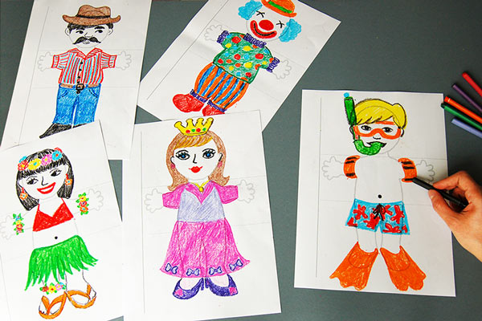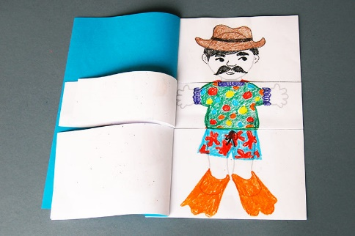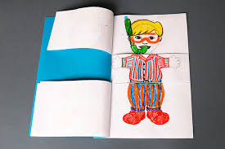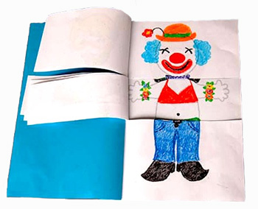
- Design a poster for a circus that is coming to Bweeng. Inlcude date, time, prices, location and acts.

Extra activities if you need them. If you do not get time to complete the extra activities don’t worry.

- Nuacht/News time – Discuss weather, what day it is today, what day was yesterday, what day it will be tomorrow, what month and season we are in, how many days in the month. Take out the calendar and fill in any special occasions coming up – birthdays , Easter ……..
Cén lá atá ann inniu? Inniu an _______. (Days of the week in Irish can be found in bua na cainte)
Cén lá a bhí ann inné? Inné an _______.
Cé lá a bheidh ann amárch? Amárach an____________.
Tá an lá ________ ( weather words can be found in bua na cainte)
- Tables race – write down 15 sums . Set the timer to 1 min and see how many you can complete. If you want more of a challenge reduce your time or increase the number of sums.

