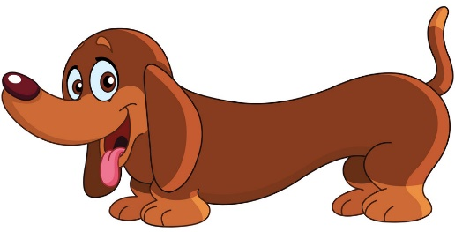
My Little Dogs
I had a little dog,
His name was Pop,
Every time he ran
His ears went flop.
I had a little dog,
His name was Trot,
He held up his tail
All tied in a knot.
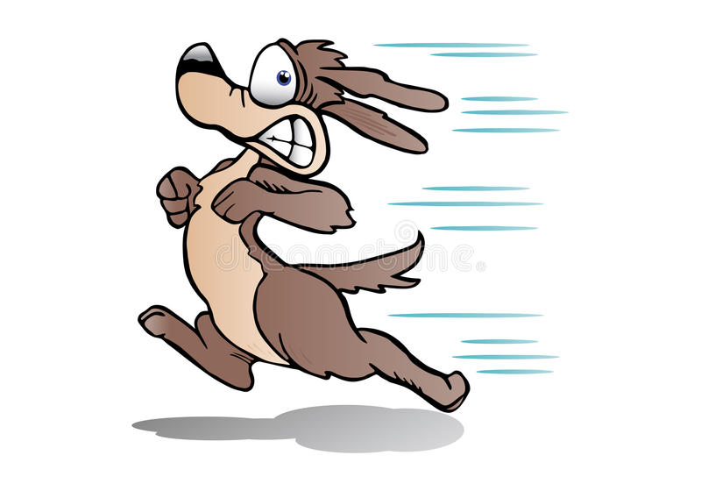
I had another dog,
His name was Blue,
When he saw a squirrel
He just about flew.
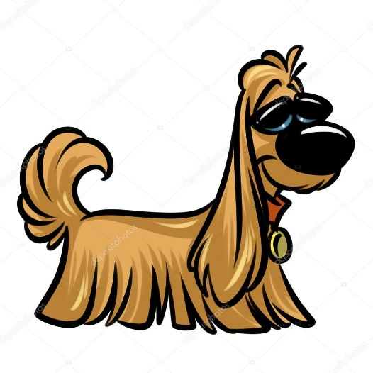
Now I have a dog,
His name is Rover.
When he wags his tail,
He waggles all over.

Questions:
Name the dogs in the poem:
___________________________________________________

Which dog do you like best?
___________________________________________________

Did you like the poem? Why?
_________________________________________________________________________________________________________________________________________________________

Do you have a pet? What is its name?
______________________________________________________________________________________________________

If you got a new puppy, what would you name it?
___________________________________________________

Can you think of another title for the poem?
___________________________________________________

