2nd class 18/5/20 -22/5/20
Hi boys and girls.
I hope you all had a lovely weekend.Keep up the good work. Here is the new timetable for this week. I have included audio clips this week of the Irish reading, these are attached as powerpoint documents.

Remember if you do not have a printer to print out the activity sheets, you can just write the answers onto a sheet or into a copy. There is no need to rewrite the questions.

I want you to e-mail me back pictures of the following work this week:
Poster of Appreciation for all the healthcare workers
Quiz time sheet
to 2ndclassmsh@gmail.com.

Please remember to say your prayers before and after communion. I encourage you all to listen in to mass on the Glantane Parish facebook page on Sunday 24th May at 11 as Fr. Coleman will be saying a mass especially for the Holy Communion classes. I posted out a picture that Fr. Coleman wants you to colour in for this Mass. All of the instructions are included in the letter that I have posted out to you.
The Lord he is my shepherd from Grow In love is the new song for this week – please listen to it on youtube with parents permission.

As this should have been your Communion weekend traditionally I would always have had a nice relaxing day planned for 2nd class in school on the Monday after their Communion so why change this tradition. I want you to have a relaxing day on Monday so all I want you to do is create a May Altar. Go out into the garden pick some flowers or pick some on your walk, draw a picture of holy Mary or put up a statue and say a Hail Mary. That’s it for the Monday work.

If you receive the picture of Holy Mary in the post you can colour that in as well. If you do not get your picture completed on Monday you can finish it during the week. Just remember it has to be done by Friday 22nd as Fr. Coleman will be collecting them from the church that day.

Hope you all have a great week.

Ms Heffernan

 | Monday | Tuesday | Wednesday | Thursday | Friday
 | Create a May Altar at home.  (See ideas below)  Colour in picture of Holy Mary if you received it in the post (see instruction below) | Quiz Time  Send photo to Ms Heffernan when this is completed  (See sheet attached)
Bua na Cainte  Theme: An Teilifis  See sheets attached  Translation sheet also attached |  | Bua na Cainte p 86  Read the words  (listen to me reading them on voice note attached)  Listen to me read the sentences 1-5, say them after me and fill in the blanks 1-5  Read sentences 1-5 yourself.  See translations on sheet attached | Bua na Cainte p 86  Listen to me read the sentences 6-10 , say them after me and fill in the blanks 6-10  Read sentences 6-10 byourself.  See translations on sheet attached  Play Feimim le mo shuilin (Eye spy) | Bua na Cainte p 87  Listen to me read the sentences at the top of the page. Say them after me.  Write the correct sentence next to pictures underneath yourself.s | Spellings and Tables test
Irish library book:  www.cj fallon.ie  Ceim ar cheim  Cairde le Cheile 2 |  |  |  |  | www.cj fallon.ie  Ceim ar cheim  Cairde le Cheile 2  P 58  Listen to me read and say the sentences after me.  Translations attached
Irish spellings p87 |  | cartún | an nuacht | clár spóirt
English reading |  | Reader p 40 Poems  Not Funny and Sore Sorcerer | A Surprise for Feena p 5 +6  (online reader)  Cj fallon.ie  2nd class, English, Wonderland | A Surprise for Feena p 7+8  (online reader)  Cj fallon.ie  2nd class, English, Wonderland
English writing |  | Answer questions attached about the above poems. | Homophones activity sheet attached  Choose 2 activities to do. | Skills book p 51 | Skills book p 52
Spellbound |  | P 58 box 1  A, B | P 58 box 2  C, D | P 58 box3  P 59 E, F | P 59 G H
Tables Revision |  | +3 | +3 | +3
Maths  Strand: Shape and space  Angles  See parent sheet attached |  | Busy at Maths p 122 | Busy at maths p 123 | Word problem sheet attached.  Remember to start with the units
Small World
It was International Nurses day on May 12th. Talk at home about the work that nurses do and why their job is so important.
Please read and talk about the picture on p 68 A.

Please read p 69 and answer the questions.

Poster – see instructions below

Religion: log onto https://app.growinlove.ie/en/user/dashboard
username trial@growinlove.ie password growinlove
Click on 2nd class book.
Next theme- listen to the stories and sing the songs. You can print some worksheets aswell..
You can light a candle and say a prayer every day.
Prayers before and after communion.

PE: It is very important to get exercise every day. The body coach is doing PE classes on his youtube channel every morning. We also love doing go noodle in school. You can sign up for free. It offers a range of exercises that can be done inside.

Art ideas-
- Colour in the picture of Holy Mary that I posted out to you. I posted them on Friday so you should get them Monday or Tuesday in the post. Please drop it back to Bweeng church when it is completed. Fr. Coleman will have a box outside the church from Monday 18th – Friday 22nd. Drop it any of these days.
Fr. Coleman will be collecting them from the church on Friday 22nd May.

- Create a May altar. May is the month of Mary so it is nice to create a scared space especially for Mary at home. If you do not a statue of holy mary draw a picture of her. Pick some flowers. Make a rosary bead. See idea below.

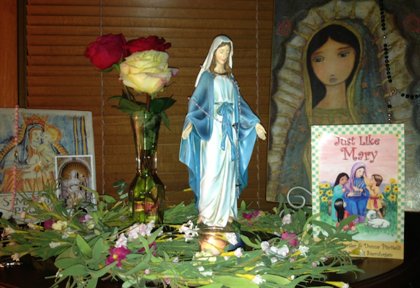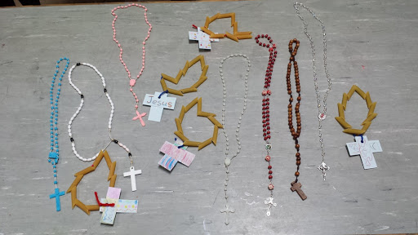

- Poster- As it was International Nurses Day on May 12 th I think it would be nice to make a poster for all the nurses, doctors and carers to show them how much we appreciate them. Thank them for all the work that they are doing during this difficult time. You can dedicate this poster to someone that you know that is a nurse, carer, doctor or someone else that you know that is working in the healthcare system. Send a picture of your poster to me and I will uplaod them to the school website.

Extra activities if you need them. If you do not get time to complete the extra activities don’t worry.

- Nuacht/News time – Discuss weather, what day it is today, what day was yesterday, what day it will be tomorrow, what month and season we are in, how many days in the month. Take out the calendar and fill in any special occasions coming up – birthdays , Easter ……..
Cén lá atá ann inniu? Inniu an _______. (Days of the week in Irish can be found in bua na cainte)
Cén lá a bhí ann inné? Inné an _______.
Cé lá a bheidh ann amárch? Amárach an____________.
Tá an lá ________ ( weather words can be found in bua na cainte)
- Tables race – write down 15 sums . Set the timer to 1 min and see how many you can complete. If you want more of a challenge reduce your time or increase the number of sums.
- Twinkl.co.uk – free access to Holy Mary activity sheets for the month of May.

