Master Your Maths 6 Answers (Week 29) Daily Work and Weekly Test (11/5/2020 – 15/5/2020)

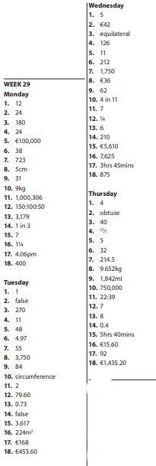

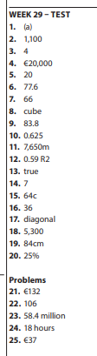

Busy at Maths Page 173
QS 1 | Qs 2 | Qs 3 | Qs 4 and 5
(a) (i) 9/20 L  (ii) 0·45L  (b)  (i) 2 452/1000L  (ii) 2·452l  (c) (i)6/10L or  3/5L  (ii) 0·6L  (d)  (i) 1 782 /1000 L  (ii) 1·782L  (e)  (i) 95/1000L or  19/200 L  (ii) 0·095l  (f)  (i) 395/1000l or 79/200 L  (ii) 0·395l  (g)  (i)7/1000 L  (ii) 0·007L  (h)  (i)7/10 L  (ii) 0·7L  (I) (i) 2 32/100 L  (ii) 2·230L  (j)  (i)8/100L or  4/25 L  (ii) 0·08l  (k)  (i) 1 1/100L  (ii) 1·01l  (l) (i) 67/1000 L  (ii) 0·067L | a) 2,500ml  (b) 763ml  (c) 1,493l  (d) 920ml  (e) 3,250ml  (f) 4,065ml  (g) 5,700ml  (h) 8ml  (i) 307ml  (j) 2,007ml  (k) 80ml  (l) 5,375ml  (m) 400ml  (n) 6,105ml  (o) 2,200ml  (p) 1,125ml  (q) 100ml  (r) 3,750ml | (a) 500ml  (b) 200ml  (c) 250ml  (d) 100ml  (e) 125ml  (f) 600ml  (g) 700ml  (h) 625ml  (i) 750ml  (j) 875m | 4.  (a) ½ l  (b) 500ml  (c) 350ml  (d) 350ml  5.  (a)  (i) 4·8l  (ii) 28·8l  (iii) 72l  (b)  (i)€33·48  (ii)€200·88  (iii)€502·20  (c)  (i) 16  (ii)€44·64

Busy at Maths Pg 174
Qs 2 | Qs 4, 5 and 6
(a) 2·762L  (b) 7·62L  (c) 21·609L  (d) 2·964L  (e) 11·61L  (f) 260·974L  (g) 5·845L  (h) 1·52L  (i) 0·374L  (j) 9·406L  (k) 1·568L  (l) 2·875L | 4.(a) 357l  4. (b)€328·44  5. 875ml  6. 24

Bun go Barr P. 116 (H)
- Suas
- Thuas
- Anuas
- Suas
- Thuas
- Anuas

Mo Laethanta Saoire
1. Cé a scríobh an ríomhphost seo?
(c) Ciara
2. Cén áit a bhfuil Ciara ar laethanta saoire?
(a) Sa Spáinn
3. Cad a chiallaíonn ‘bhí an trácht ag bogadh chomh mall
le seilide’?
(a) Bhí na carranna ag dul go mall
4. Cé acu abairt atá fíor?
(b) Ní raibh duine ar bith gortaithe
5. Conas a tharla an timpiste?
(b) Bhí ola ar an mbóthar
6. Conas a mhothaíonn Ciara agus í ar saoire go fóill?
(a) Tá an teas ag cur isteach uirthi

