4th Class (25/5/2020 – 29/5/2020)
Dear parents and children,
It’s the beginning of another week and as I sit here writing this, the sun is shining outside. I’m fully aware that the work may be getting harder to complete these days, but you are doing a great job.
Thanks again to all of you who have emailed me samples of your children’s work and keeping me up to date on how they are getting on. I really appreciate it and it looks like they are being kept busy too!
This week again, all teachers in our school are asking parents to email some pictures of the children’s work to their teacher. Each teacher is asking for two specific pieces of work to be sent to them, so that they can see how the children are getting on. In relation to 4th class, I would like to see the Busy at Maths 4 p.141 and also Witches, Spiders and Cowboys (Reader) Questions from ‘Matilda’ (the children will know these). I would greatly appreciate pictures of this work being sent to my email address, which is twalshbweengns@gmail.com
The answers to the work this week in Busy at Maths 4 and Bun go Barr 4 can be accessed on the school website from Friday 29th May, and you can correct your work from the week.
Remember to learn your spellings every night and complete a spelling test on Friday.

Again this week, 4th class will be doing Irish work from Bun go Barr 4. This can be accessed through the CJ Fallon website, who are the publishers of the books. There is a section where parents and pupils can log into the website and gain access to a great selection of school books, including the Bun go Barr series. The pages we will be using can also be accessed in this document, after the spellings, in case anyone cannot access them online.
- To access the book online (www.cjfallon.ie), log into the parent/student section on the website.
- A list of resources can be viewed, so then choose from the list
- Level – primary
- Class – 4th
- Subject – Gaeilge
- Series – Bun go Barr
- Title – Bun go Barr 4
- Resource – Online Book
- Then click on the button “View resource” below and you will be able to access the book and flick through the pages.
The book pages for this week are also available in this document after the spellings.

- This week’s Science pages can also be accessed from the ‘CJ Fallon’ website.
- It can be accessed in the ‘SESE’ subject section.
- It will then be in ‘Science’.
- The name of the book is ‘Science Quest 5’.
- The book pages for this week are also available in this document after the spellings.

The accompanying 4th class Gaeilge powerpoint presentation that was attached to this week’s homework section will provide children with the meaning of some words in this week’s Irish story. They can also click on the speaker button to hear the story being read to them, which will help with pronunciation of any words they may be having difficulty with.

I’ve attached a Maths explanation sheet on long multiplication on the website page, but I’ve also attached it to the end of this document to help the children with long multiplication. This will be revised when they return to school and they’ll be covering a lot of these types of sums in school next year, so please don’t stress over them, let the children do what they can.
Have a great week,
Mr. Walsh
Don’t forget to write the date and page number on top of your page in your copybook so we can find it again.

Monday 25/5/2020
Gaeilge: Bun go Barr 4: Read p. 16 (down to Monday), p. 18 E
(Bun go Barr 4 p.14 – p.18 can be found near the end of this word document)
Irish Spellings learn (1-2)
Maths: Busy at Maths p. 141 Q. 1
English: Witches, Spiders and Cowboys (Reader) Read p. 146-p.150, p.151 (Q.1-5)
Write Here: Complete next page
English Spellings (1-4)
Religion: ‘Grow in Love’, Read p. 79 and think about the words you would say in the Activity on p. 79
Science: Read ‘In a Spin’ p. 20 (see Science ‘In a Spin’ in this document after the spellings). On p. 20 Activity (B) Fill in the blanks.

Tuesday 26/5/2020
Gaeilge: Bun go Barr 4: Read p. 16 (down to Tuesday), p. 17 C
(Bun go Barr 4 p.14 – p.18 can be found near the end of this word document)
Irish Spellings: learn (3-4)
Maths: Busy at Maths p. 141 Q. 2
English: Witches, Spiders and Cowboys (Reader) p.151 (Q.6-10)
English Spellings (5-8)
Write Here: Complete the next page
Religion: ‘Grow in Love’, Read p. 80 and p. 81
Science: Read and answer the questions on p. 21 orally (no need to write them down) (see Science ‘In a Spin’ in this document after the spellings).
___________________________________________________________

Wednesday 27/5/2020
Gaeilge: Bun go Barr 4: Read p. 16 (down to Wednesday), p. 17 B (1-4)
(Bun go Barr 4 p.14 – p.18 can be found near the end of this word document)
Irish Spellings (5-6)
Maths: Busy at Maths p. 141 Q. 3-6
English: Wordwise p. 80 A+B
English Spellings (9-12)
Write Here: Complete the next page
Science: Read ‘In a Spin’ p. 22 and draw a diagram of the experiment and answer questions (see Science ‘In a Spin’ in this document after the spellings).
___________________________________________________________

Thursday 28/5/2020
Gaeilge: Bun go Barr 4: Read p. 16 (down to Thursday), p. 17 B (5-8)
(Bun go Barr 4 p.14 – p.18 can be found near the end of this word document)
Irish Spellings (7-8)
Maths: Busy at Maths p. 143 Q. 1-6
English: Wordwise p. 80 C+D
English Spellings (13-16)
Write Here: Complete the next page
__________________________________________________________

Friday 29/5/2020
Gaeilge: Complete any work that was not finished during the week.
Complete Irish spelling test and have someone correct it later and give a mark out of 8.
Maths: Complete any work that was not finished in Busy at Maths during the week.
English: Complete any work that was not finished during the week
Write Here: Complete the next page
Complete English Spelling test and have someone correct it and give you a mark
out of 16
Religion: Complete any work that was not finished during the week.
Science: Complete any work that was not finished during the week.
___________________________________________________________

Extra material
(choose from the list, do not worry if you cannot complete everything 😊)
RTE School Hub – RTE’s Home School Hub continues every day. Please find the timetable attached to find out what is being taught this week during the lessons.
P.E.- It is so important to keep active boys and girls. Every morning from 9am The body Coach for kids is live for 30 minutes on his You Tube channel, Just Dance is another great option for dance routines.
CJ Fallon online- English- My Read At Home 4- This week focus on Week 26. Read one each day and answer questions orally.
Art – Visit https://www.youtube.com/results?search_query=drawing+step+by+step+for+kids to follow some brilliant drawing tutorials
Music Choose new song and learn it by listening to it on YouTube
Reading Eggs - Please continue with Reading Eggs if your free trial has not expired.
The Primary Planet - Complete some of the Primary Planet tasks which are put up on their website each morning at 9.20am.
Free Writing: Write a story with a title of your choice.
Gaeilge: Choose a cartoon to watch on TG4
SPHE: Pick one chore or good deed that you could do each day
Library Books - make sure you are reading library books at home. You can read in the garden (if it’s nice and sunny) or in your bedroom, pick a spot where you feel comfortable.
Visit the link https://www.worldofdavidwalliams.com/ to listen to a free audio book from David Walliams. He is currently releasing one a day.
___________________________________________________________

I would love to know how you all are getting on at home. An adult can email me pictures of your work and if you want to ask me any questions you can. Please do not worry about getting all the work completed, just try your best!
The answers for all maths questions from ‘Busy at Maths 4’ and ‘Bun go Barr 4’ will be posted on the schools website later on in the week, so that the children can correct their work.
Parents, if you have any questions/queries please contact me also.

My email is:
twalshbweengns@gmail.com

I really hope I will see ye all soon.
Take care,
Mr. Walsh

Gaeilge spellings 25/5/2020
- vása = vase
- bláthanna = flowers
- raidió = radio
- cuirtíní = curtains
- líomanáid = lemonade
- dochtúir = doctor
- oideas = prescription
- solas = light

English spellings 25/5/2020
- tulip
- human
- music
- usual
- computer
- unicorn
- unicycle
- cucumber
- unique
- universe
- solution
- ask
- vase
- lava
- bath
- nasty

Gaeilge - Bun go Barr 4 (p.14 to p.18)
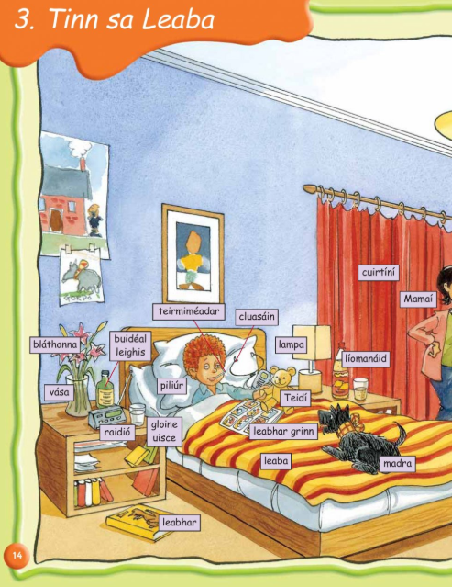

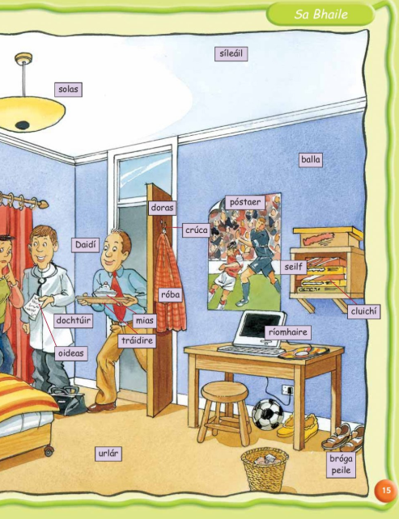

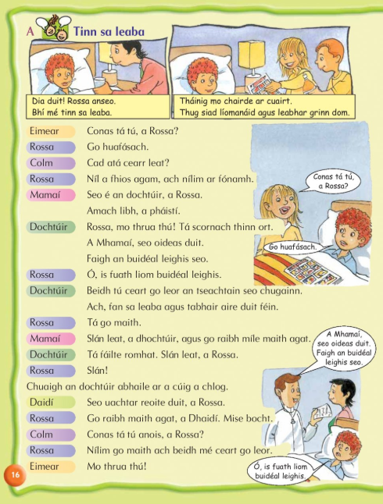
Thursday
Wednesday
Tuesday
Monday

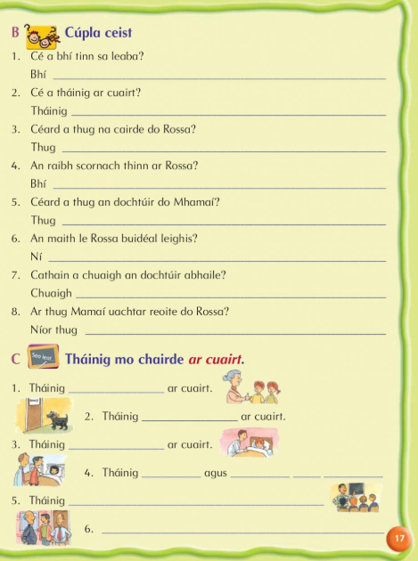

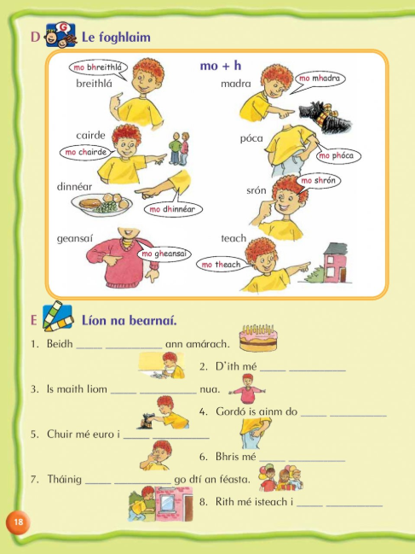

Thursday
Wednesday
Tuesday

Science
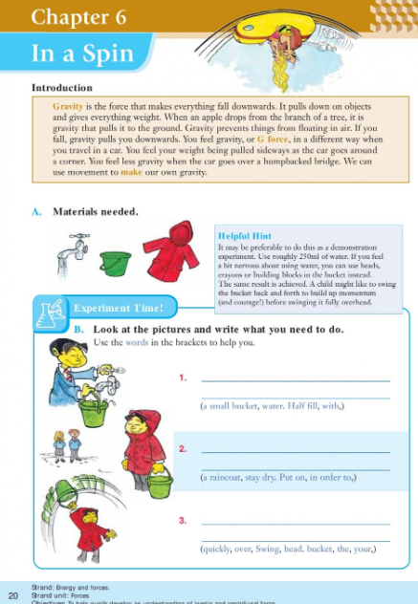
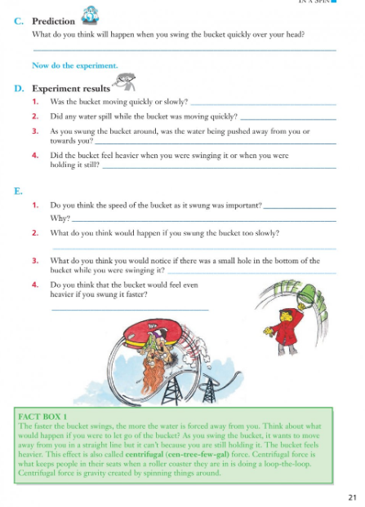

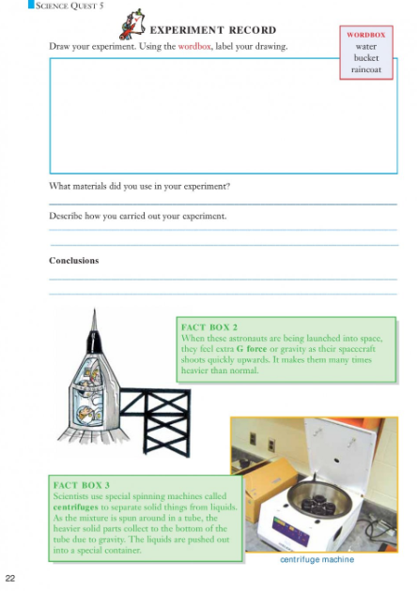

Long Multiplication
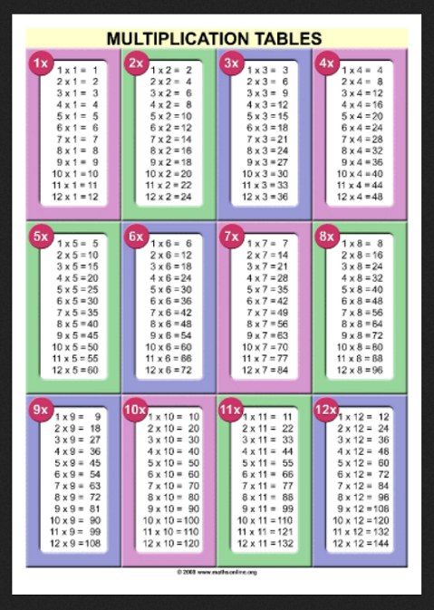

Long multiplication is explained below.
