4th Class (2/6/2020 – 5/6/2020)
Dear parents and children,
I hope you all had a nice bank holiday weekend. We had lovely weather and I hope you were able to get some sunshine and enjoy yourselves.
We will continue with work this week, but we will work as if you were in school and work from Tuesday to Friday, as you would not be attending school on Monday anyway.
Thanks again to all those who have been in contact during the week, it was great to hear from you all and letting me know how the children are getting on. If you are able this week, I would greatly appreciate pictures of any two pieces of work that the children may do. They can be sent to my email address, which is twalshbweengns@gmail.com
The answers to the work this week in Busy at Maths 4 and Bun go Barr 4 can be accessed on the school website from Friday 5th June, and you can correct your work from the week.
Last week was your last spelling test in 4th class, so I am not attaching any spellings this week. Well done everyone on doing great work in your tests throughout the year!!

Again this week, 4th class will be doing Irish work from Bun go Barr 4. This can be accessed through the CJ Fallon website, who are the publishers of the books. There is a section where parents and pupils can log into the website and gain access to a great selection of school books, including the Bun go Barr series. The pages we will be using can also be accessed in this document, after the spellings, in case anyone cannot access them online.
- To access the book online (www.cjfallon.ie), log into the parent/student section on the website.
- A list of resources can be viewed, so then choose from the list
- Level – primary
- Class – 4th
- Subject – Gaeilge
- Series – Bun go Barr
- Title – Bun go Barr 4
- Resource – Online Book
- Then click on the button “View resource” below and you will be able to access the book and flick through the pages.
The book pages for this week are also available in this document after the spellings.

The accompanying 4th class Gaeilge powerpoint presentation that was attached to this week’s homework section will provide children with the meaning of some words in this week’s Irish story. They can also click on the speaker button to hear the story being read to them, which will help with pronunciation of any words they may be having difficulty with.
Have a great week,
Mr. Walsh
Tuesday 2/6/2020
Gaeilge: Bun go Barr 4: Read p. 20 (1-4), p. 22 C
(Bun go Barr 4 p.20 – p.22 can be found near the end of this word document)
Maths: Busy at Maths p. 144 Q. 1+2 (e.g. Q. 1 (a) 2 | 4 8 2___
2 4 1
English: Wordwise Read p. 82 and p. 83 A
Write Here: Complete the next page
Religion: ‘Grow in Love’, Read p. 82 and p. 83
___________________________________________________________

Wednesday 3/6/2020
Gaeilge: Bun go Barr 4: Read p. 20 (5-8), p. 22 B (Q. 1-4)
(Bun go Barr 4 p.20 – p.22 can be found near the end of this word document)
Maths: Busy at Maths p. 145 Q. 2+3
English: Wordwise p. 88 (Fill in the blanks. Just write the answers in the correct order)
Write Here: Complete the next page
Religion: ‘Grow in Love’, Read p. 84
___________________________________________________________

Thursday 4/6/2020
Gaeilge: Bun go Barr 4: Read p. 21 (9-12), p. 22 B (Q. 5-8)
(Bun go Barr 4 p.20 – p.22 can be found near the end of this word document)
Maths: Busy at Maths p. 146 Q. 1+2
English: Wordwise p. 89 D
Write Here: Complete the next page
__________________________________________________________

Friday 5/6/2020
Gaeilge: Bun go Barr Read p. 21 (13-15)
Complete any work that was not finished during the week.
Maths: Complete any work that was not finished in Busy at Maths during the week.
English: Complete any work that was not finished during the week
Write Here: Complete the next page
Religion: Complete any work that was not finished during the week.
___________________________________________________________

Extra material
(choose from the list, do not worry if you cannot complete everything 😊)
RTE School Hub – RTE’s Home School Hub continues every day. Please find the timetable attached to find out what is being taught this week during the lessons.
P.E.- It is so important to keep active boys and girls. Every morning from 9am The body Coach for kids is live for 30 minutes on his You Tube channel, Just Dance is another great option for dance routines.
CJ Fallon online- English- My Read At Home 4- This week focus on Week 27. Read one each day and answer questions orally.
Art – Visit https://www.youtube.com/results?search_query=drawing+step+by+step+for+kids to follow some brilliant drawing tutorials
Music Choose new song and learn it by listening to it on YouTube
Reading Eggs - Please continue with Reading Eggs if your free trial has not expired.
The Primary Planet - Complete some of the Primary Planet tasks which are put up on their website each morning at 9.20am.
Free Writing: Write a story with a title of your choice.
Gaeilge: Choose a cartoon to watch on TG4
SPHE: Pick one chore or good deed that you could do each day
Library Books - make sure you are reading library books at home. You can read in the garden (if it’s nice and sunny) or in your bedroom, pick a spot where you feel comfortable.
Visit the link https://www.worldofdavidwalliams.com/ to listen to a free audio book from David Walliams. He is currently releasing one a day.
___________________________________________________________

I would love to know how you all are getting on at home. An adult can email me pictures of your work and if you want to ask me any questions you can. Please do not worry about getting all the work completed, just try your best!
The answers for all maths questions from ‘Busy at Maths 4’ and ‘Bun go Barr 4’ will be posted on the schools website later on in the week, so that the children can correct their work.
Parents, if you have any questions/queries please contact me also.

My email is:
twalshbweengns@gmail.com

I really hope I will see ye all soon.
Take care,
Mr. Walsh

Gaeilge - Bun go Barr 4 (p.20 to p.22)
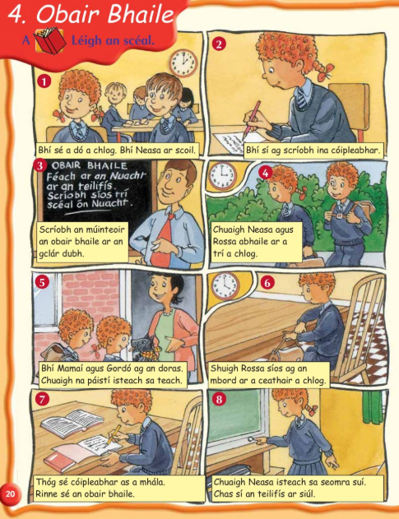

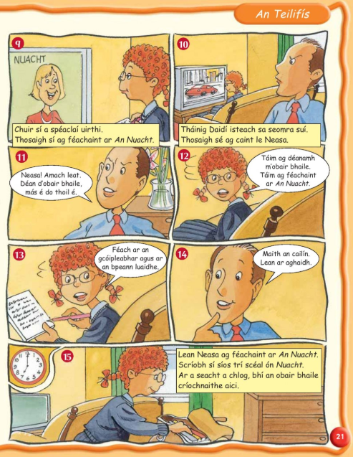

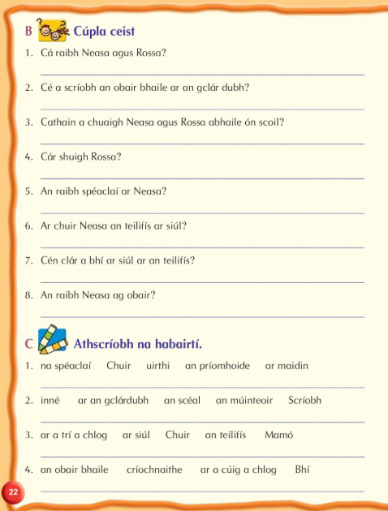
Was Neasa working?
What programme was on the television?
Did Neasa turn on the television?
Was Neasa wearing glasses?
Where did Rossa sit?
When did Neasa agus Rossa go home from school??
Who wrote on the blackboard?
Where were Neasa and Rossa?

