Junior Infants Work 2nd – 5th June
Dear parents,
I hope you all had a lovely bank holiday weekend and enjoyed the sunshine. Here is this week’s school work for junior infants. I have not assigned work for Monday as it is a bank holiday but feel free to get a start on the weeks work if it suits you better to do so. As always, I can be reached by email at infants.bweengns@gmail.com.
As we are nearing the end of the school year I’m kindly asking you all to gather any book scheme books that you may have at home and put them into a plastic bag with your child’s name on the bag. Mrs. Sheehy or Ms. Buckley will be in touch shortly to arrange collection. Books that Junior Infants have at home include:
- Where Can GG Sit? (reader – CJ Fallon)
- GG is Too Big (reader – CJ Fallon – the majority of these were collected in school before lockdown but you may still have it)
- Any small library books – PM readers or Wonderland readers
I enjoy seeing all your fabulous pictures of the school work and fun activities that you are doing each week so keep sending them. I am proud of all your hard work so well done everyone!
This week I am going to request that you send me images of certain activities during the week!
1. Just Phonics page 76
2. Busy at Maths page 117

Have a great week,
Miss Harrington

 | Monday | Tuesday | Wednesday | Thursday | Friday
Reading |  | Reading Comprehension Sheet 1 -am words. (If it’s not possible to print these, just read and answer the questions orally!)  Reading Eggs – One Lesson | Reading Comprehension Sheet 2 -ub words. Read and answer questions.  Reading Eggs – One Lesson | Reading Comprehension Sheet 3 -Read and choose the correct sentence.  Reading Eggs – One Lesson | Just Phonics page 76 – Read and colour the correct sentence.  Reading Eggs – One Lesson
Phonics |  | Just Phonics page 68- Revision of initial sounds (Write the correct initial letter) | Just Phonics page 69- Revision of initial sounds (Write the correct initial letter) | Just Phonics page 70- Revision of final sounds (Write the correct final letter) | Just Phonics – page 71 Revision of final sounds  (Write the correct final letter)
Writing |  | Green Letter Copy 2 – revise writing letters q and j | Revision All Write small book p.32  (revise letters r,n,m,p,h,b) | Green Letter Copy 2 – revise writing letters x and z | Revision All Write small book p.39  (revise letters v,w,x,l,t,u,y)
Skills Book |  | Skills Book page 62 |  | Skills Book page 63
Oral Language | Theme for this week again is linked to Aistear ‘The Garden Centre’ – In Oral Language we will focus on the theme minibeasts.  What is a minibeast?  - A minibeast is a small animal or ‘creepy crawly’.  - Minibeasts have no backbone.  - Minibeasts do not have a skeleton on the inside.  - Some minibeasts have a hard shell to live in.  - Minibeasts can be found on land, water and air.  - There are a lot of different kinds of minibeasts. Can you name any?  Vocabulary – spider, slug, beetle, butterfly, woodlouse, daddy-long-legs, wasp, ladybird, snail, dragonfly, ant, worm, fly, bee, caterpillar, millipede, earwig,  Read to the powerpoint story ‘The Cautious Caterpillar’ (on website).  Chat about the story and answer the following questions orally-  - What kind of creature is cody at the beginning of the story?  - How many legs does Cody have when she is a caterpillar?  - Can you name two creatures that Cody speaks to about becoming a caterpillar?  - When Cody is still a caterpillar, what does she say about the idea of flying?  - Why doesn’t Cody want to become a butterfly?  - What does the grasshopper say having six legs is plenty for?  - What does Cody finally do that is very brave?  - Why does Cody tell the caterpillar not to worry at the end of the story?  Some fun activities linked to the story (on website) – Make Cody’s butterfly cupcake recipe, play the ‘What am I?’ interactive powerpoint game, Cody the caterpillar’s minibeast count.
Maths |  | This week we are focusing on money.  Collect as many 1c,2c and 5c coins as you can. Place them in a pile on the table. Give your child 3 plastic cups. Using post-its label one box 1c, another box 2c and the last box 5c. Ask your child to sort the coins into the correct boxes.  Place some 1c, 2c and 5c coins in a bag. You and your child should not be able to see the coins. Ask him/her to feel about in the bag and pick a coin. S/he must guess what value each coin is and if successful they can keep that coin.  Busy at Maths pages 113 and 114 | Today you will look at adding coins. Give a ‘purse’ or a ‘moneybox’ to your child with eg: 2 x 1c coins in it. Start with 1c coins only and count how many.  Then mix and match between 1c and 2c coins. How much do you have in your purse now?  Repeat this several times.  Busy at Maths page 115 | Set up a simple shop today and tomorrow using fruit and veg items from the kitchen. Label items using post-its if possible. Items should be priced between 1c and 5c. Children can take turns being the customer and the shopkeeper and should get the opportunity to exchange real money.  Busy at Maths page 116 | Play shop again today.  Busy at Maths page 117 and 118

Other activities to try:
Gaeilge
This week we will look at Gaeilge vocab relating to ‘The Garden’ – ‘An Gairdín’

See video of the song ‘Cad atá sa ghairdín?’ on website.
Vocab:
gairdín (garden) crann (tree) balla (wall)
bláthanna (flowers) geata (gate) luascán (swing)
See-saw (see-saw) mór (big)

Phrases/Abairtí:
Cad atá sa ghairdín? (What is in the garden?)
Tá ___________ sa ghairdín. ( _________ is in the garden.)

Children can have fun singing along. They can also choose 4 or 6 items and draw them in a ‘BINGO card’. Parents can call irish words one by one and the children can cross the picture out if they have it.
They can also draw a simple ‘gairdín’ (garden) on a blank A4 page. Parents can call out the phrase ‘Cuir __________ (eg: crann) sa ghairdín’. Children then draw that item in the garden. Continue until all items are in the garden. Then ask the child the question: Cad atá sa ghairdín? And encourage them to answer with ‘Tá crann/geata etc sa ghairdín’.

Days of the week/Weather
Each morning in school we always start our day by reciting the days of the week and we fill in our calendar and weather chart so here are some questions to focus on each morning-
-What day is it today? What day was it yesterday? What day will tomorrow be?
-What month/season is it?
-What is the weather like today?
-Cén saghas lae é? (What sort of day is it?) Tá an lá ___________. fliuch(wet), fuar(cold), te (hot), tirim (dry), gaofar (windy), scamallach (cloudy). Tá an ghrian sa spéir. (The sun is out). Tá sé ag cur báistí. (It is raining)
PE
- Join The Body Coach Joe Wicks live every morning at 9am
- ‘Just Dance’ on Youtube has lots of fun dance activities for infants - ‘I Like to Move It’, ‘I’m a Gummy Bear’, ‘Trolls: Can’t Stop the Feeling’, ‘I’m Gonna Catch You’, ‘Shake it Off’, ‘Walking on Sunshine’.
- www.fyffesfitsquad.ie have online lessons daily.
- Why not try some kids yoga on the CosmicKids Yoga channel on youtube
- mollys_mini_movers provides free fun fitness classes for kids aged 3-8 every Wednesday on her Instagram page (10am – 3-5 years , 10.30am – 5-8years, 11:15 – Montessori level)

Aistear/Art
Our theme for Aistear is ‘At the Garden Centre’. Here are some activities around the theme to have some fun with:
- Role Play – Pretend play using whatever equipment is available to you at home eg: spades, trowels, rakes, flowers, seeds, hose, flower pots, watering can, garden gloves, equipment for selling items eg: cash register, money
- Messy Play – Plant some seeds (even the seeds from an apple will do) What tools do you need? – Have the opportunity to ‘garden’ and explore soil and using tools like trowels, rakes etc
- Playdough – Can you make some beautiful summer flowers using your playdough? Can you name the parts of your flower?
- Arts and Crafts – Draw/Paint/Create a picture of summer flowers using whatever arts and crafts materials you would like. Send me your creations- I would love to see

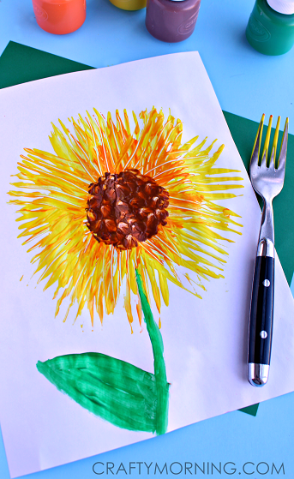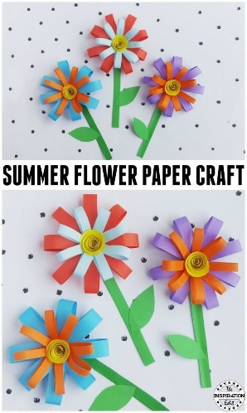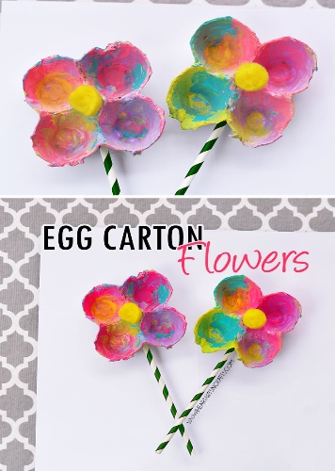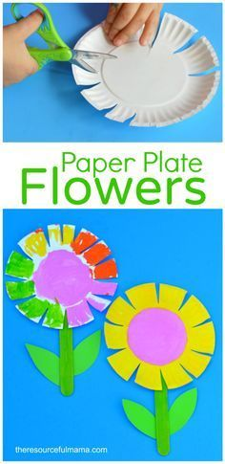

SESE
See activities on ‘minibeasts’ in Oral Language section above
Reading Comprehension Sheet 1
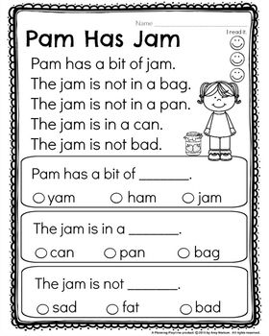

Reading Comprehension Sheet 2
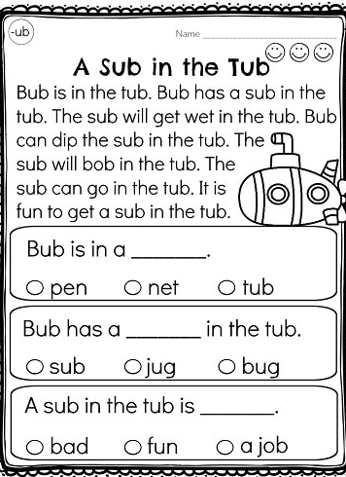
Reading Comprehension Sheet 3

