2nd class 11/5/20 – 15/5/20
Hi boys and girls.
Well done to you all. It looks like you are all working really hard. Keep up the good work. Here is the new timetable for this week.
If you do not have a printer to print out the activity sheets, you can just write the answers onto a sheet or into a copy. There is no need to rewrite the questions.
I want you to e-mail me back pictures of the following work this week:
I want you to create a poster about the month you were born in and send me a picture when it is complete.
Communion sentences (Fridays writing activity) to 2ndclassmsh@gmail.com.

Please remember to say your prayers before and after communion. I encourage you all to listen in to mass on the Glantane Parish facebook page on Sunday at 11. I have attached new song words also for this online Mass. – Go now in peace.

I know this week you should be preparing for your Communion and it is very sad that we will not be celebrating it on Saturday but we have to keep ourselves and our families safe by staying at home. I can guarantee though when we get our new date it will be a very special day indeed and I cannot wait to celebrate with you all on that very important day. But for now we need to stay positive and stay safe.

My news for this week is; Aoife turned 1 on Saturday. Unfortunately she couldn’t spend it with her grandparents or cousins but she still had a lovely day and got loads of presents and cards in the post. The only party guests she had were Mammy, Daddy and her teddies. So as we are still in the party mood in this house I have included some birthday themed lessons this week in our timetable.

Just a reminder to e-mail a photo of your child to 2ndclassmsh@gmail.com by Monday 11th May.

Hope you all have a great week.

Ms Heffernan

 | Monday | Tuesday | Wednesday | Thursday | Friday
Bua na Cainte  Theme: Breithlá  See sheets attached  Translation sheet also attached | An Chóisir (the party)  Look at the picture and Bí ag caint (Talk about the picture)  Tá _____ ar an mbord/faoin mbord. (on/under the table)  Tá _____ag Mamaí.  Mammy has___  Tá na páistí ag _____.  The children are____  Read the words in the picture. | An Chóisir  Read the words in the balloons.  Read the story no.1 – 3.  See translations on sheet attached | Read the story no 4-7.  See translations on sheet attached  Play Feimim le mo shuilin (Eye spy) | An choisir Questions  See sheet attached | Spellings and Tables test
Irish library book:  www.cj fallon.ie  Ceim ar cheim  Cairde le Cheile 2 |  |  |  | P 20 Lá Bréithe | P21
Irish spellings | D’ith (ate) | D’ól (drank) | balúin | Bronntanais (presents)
English reading | Read at home 2 p 7  Invitation  Read and answer questions orally.  (cj fallon.ie) | Poem see attached  Read and Find the rhyming words | Reader p 37 | Reader p 38
English writing | Design your own birthday invitation. Be sure to include the date, time and location.  You can use template attached or draw your own. | Birthday poster  See instructions below | Birthday poster  See instructions below | Birthday poster  See instructions below  Send a picture to Ms Heffernan | Write down a few sentences about how you are feeling about your Communion being postponed.  It’s ok to feel a mixture of feelings. Be honest.  Now write down a few things that you looking forward to when you finally get to celebrate your Communion.  Draw some happy images underneath.  Display this in your house as reminder of the good things that are to come.  Send a picture of your writing to Ms Heffernan.
Spellbound | P 56 box 1  P 56 A, B | P 56 box 2  P 56 C | P 56 box 3  P 57 D | P 56 box 4  P 57 E, F | P 57 G
Tables Revision | +2 | +2 | +2 | +2
Maths Online  Strand: Measures  Revision of weight, capacity, time  Problem solving | www.topmarks.co.uk  maths games  7-11 yr olds  Measures  Capacity countdown  You can adjust settings to make it as tricky as you want.  Coconut ordering – capacity  Problem solving – magic squares | www.topmarks.co.uk  maths games  7-11 yr olds  Measures  Mostly Postie  You can adjust settings to make it as tricky as you want.  Coconut ordering – mass(weight)  Problem solving –  Power Lines | www.topmarks.co.uk  maths games  7-11 yr olds  Measures  Calendar  You can adjust settings to make it as tricky as you want.  5- 7 yrs: measures  Time tools  On time | www.topmarks.co.uk  maths games  5-7 yr olds  Addition and subtraction games  Daily 10  Post sorting  You can adjust settings to make it as tricky as you want. | Art ideas see below

Poster:
My birthday month poster – Write the date of your birthday on top of the page.
Write the season which your birthday falls in, write about your favourite birthday memory and present, Draw or stick on a picture.
What is your favourite thing to do on your birthday?
Find out if anyone else in your family has a birthday on the same day or month as you., find out if someone famous has a birthday on the same day or month as you ,
Find out if there are any special occasions celebrated in the month you were born in,
Find out what foods ripe in the month you were born in ( can be found in small world workbook).

Display all of the information you find out on a sheet , draw pictures, stick on pictures, write sentences. Be creative.

Religion: log onto https://app.growinlove.ie/en/user/dashboard
username trial@growinlove.ie password growinlove
Click on 2nd class book.
Next theme- listen to the stories and sing the songs. You can print some worksheets aswell..
You can light a candle and say a prayer every day.
Prayers before and after communion.

PE: It is very important to get exercise every day. The body coach is doing PE classes on his youtube channel every morning. We also love doing go noodle in school. You can sign up for free. It offers a range of exercises that can be done inside.

Art ideas-

Wall decorations -
- Find any size piece of paper, coloured, brown paper, newspaper, white paper. Fold it in accordion style folds.
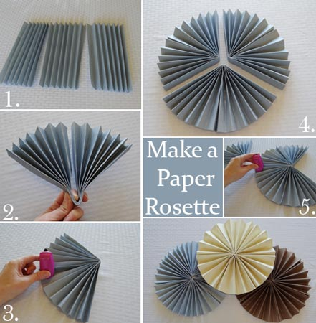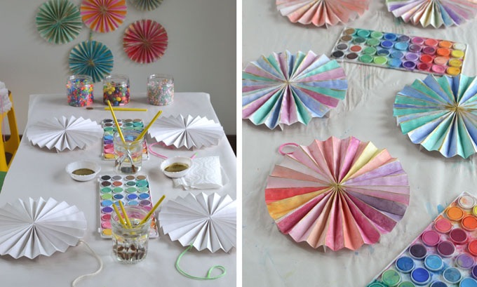

Other paper folding crafts
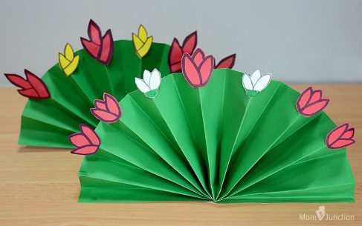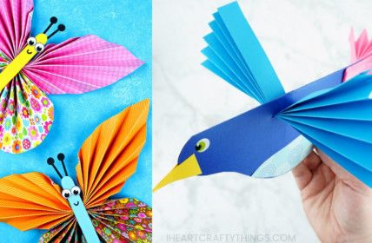
Extra activities if you need them. If you do not get time to complete the extra activities don’t worry.

- Nuacht/News time – Discuss weather, what day it is today, what day was yesterday, what day it will be tomorrow, what month and season we are in, how many days in the month. Take out the calendar and fill in any special occasions coming up – birthdays , Easter ……..
Cén lá atá ann inniu? Inniu an _______. (Days of the week in Irish can be found in bua na cainte)
Cén lá a bhí ann inné? Inné an _______.
Cé lá a bheidh ann amárch? Amárach an____________.
Tá an lá ________ ( weather words can be found in bua na cainte)
- Tables race – write down 15 sums . Set the timer to 1 min and see how many you can complete. If you want more of a challenge reduce your time or increase the number of sums.
- Birthday activity sheets attached.

