Master Your Maths 5 Answers (Week 27) Daily Work and Weekly Test (20/4/2020 – 24/4/2020)
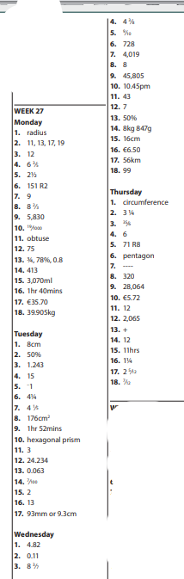

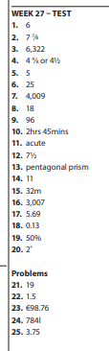

Busy at Maths 5 Answers Chapter 25 (Weight)
p. 136
Q. 1 (a) 9/1000kg = 0.009kg Q. 2 (a) 553/1000kg = 533g
(b) 14/1000kg = 0.014kg (b) 6/1000kg = 6g
(c) 3/1000kg = 0.003kg (c) 72/1000kg = 72g
(d) 416/1000kg = 0.416kg (d) 272/1000kg = 272g
(e) 228/1000kg = 0.228kg (e) 650/1000kg = 650g
(f) 67/1000kg = 0.067kg (f) 165/1000kg = 165g
(g) 923/1000kg = 0.923kg (g) 810/1000kg = 810g
(h) 503/1000kg = 0.503kg (h) 10/1000kg = 10g
(i) 156/1000kg = 0.156kg (i) 384/1000kg = 384g
(j) 830/1000kg = 0.830kg (j) 700/1000kg = 700g
(k) 449/1000kg = 0.449kg (k) 990/1000kg = 990g

Q 3 (a) 2,736g (b) 6,259g (c) 4,372g (d) 3,257g (e) 8,057g
(f) 5, 418g (g) 6,450g (h) 3,300g (i)3,709g (j) 8,731g
(k) 5,008g

Q 4 (a) 1.737kg (b) 1.459kg (c) 6.281kg (d) 2.046kg (e) 0.990kg
(f) 3.553kg (g) 8.300kg (h) 6.430kg (i) 7.084kg (j) 5.308kg
(k) 9.004kg

Maths Fact = 170kg

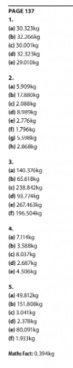

Bun Go Barr P.104 + 105
A | C | E
- Shuigh  - D’fhan  - D’inis  - Bhuail  - Leag  - Mhoilligh  - Ní dhearna | - Liom  - Duit  - Leis  - Uirthi  - Orainn  - Libh  - Dóibh  - Orm | - Bhí  - Tháinig  - D’ith  - Chonaic  - Rug  - Fuair  - Rinne  - Chuala  - Chaith  - Dúirt  - Chuaigh

