^{2nd class} 8/6/20 - 12/6/20
Hi boys and girls.

I hope you all had a lovely weekend. Keep up the good work. Here is the new timetable for this week. I hope you all received your activity pack. I will be including some activities from that this week and next week.

I want you to e-mail me back pictures of the following work this week:
Maths book p 154
Small world p 83
to 2ndclassmsh@gmail.com.

Please dust off your World Book Day costume and find your favourite book as we will be having a “virtual world book day” next week. Details of this will be included in next week’s timetable.

Mrs. Sheehy also wanted me to include an important note about an e-mail she has sent out to all parents regarding a new administrative system Aladdin Connect that we intend to implement this week. It will enable us to send the end of year report in manner that is GDPR compliant. Please read this e-mail carefully and if you did not receive this e-mail please let me know.

Hope you all have a great week.

Ms Heffernan

 | Monday | Tuesday | Wednesday | Thursday | Friday
 |  |  |  |  | Spellings and Tables test
Reading | A Surprise for Feena p  21 +22  (online reader)  Cj fallon.ie  2nd class, English, Wonderland | A Surprise for Feena  New story: Fun at the big lemon teapot p 23 +24  (online reader)  Cj fallon.ie  2nd class, English, Wonderland | A Surprise for Feena p 25 +26  (online reader)  Cj fallon.ie  2nd class, English, Wonderland | A Surprise for Feena p  27 +28  (online reader)  Cj fallon.ie  2nd class, English, Wonderland | A Surprise for Feena p  29 + 30  (online reader)  Cj fallon.ie  2nd class, English, Wonderland
Writing | Skills book p 60  P 62/63 game | Skills book p 64 | All write Now p 59 | All Write Now p 60
Spellbound | P64 box 1  A B | P 64 box 2  C D | P 64box 3  E F | P 64 box 4  G H
Tables Revision | +6 | +6 | +6 | +6
Maths  Strand:  Number  . | Busy at Maths p 154 | Busy at maths p 155 | Busy at Maths p 156
Small World |  | Small world P 83 | Small world p 85 Shadows |  | Small World p 86
 | Science experiment A  (attached)  Experiment write up sheet attached also. If you do not have a printer write the answers onto a sheet or into your copy. |  |  | Science experiment B  (attached)  Experiment write up sheet attached also. If you do not have a printer write the answers onto sheet or into your copy.
Activity pack |  | Choose an activity from the list below. | Choose an activity from the list below. |  | Choose an activity from the list below
 |  |  |  |  | Art ideas see below
Art ideas-
Shadow drawings
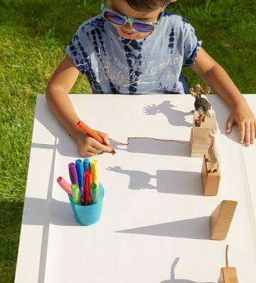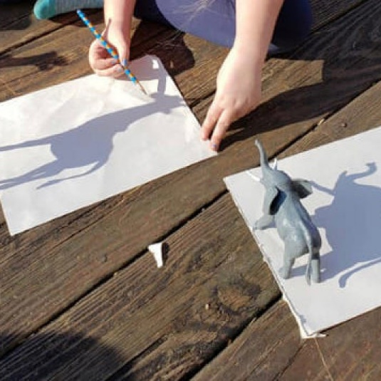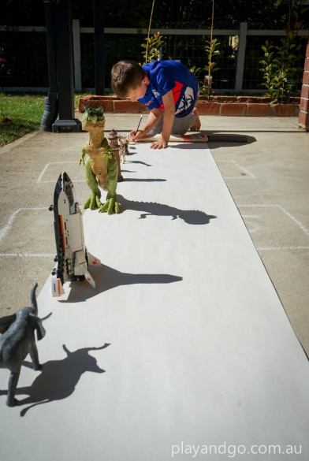
Sun art ideas:
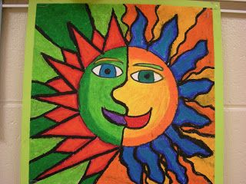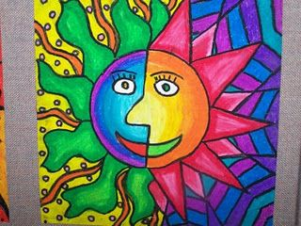

Make a sun themed card to “brighten” up someone’s day:
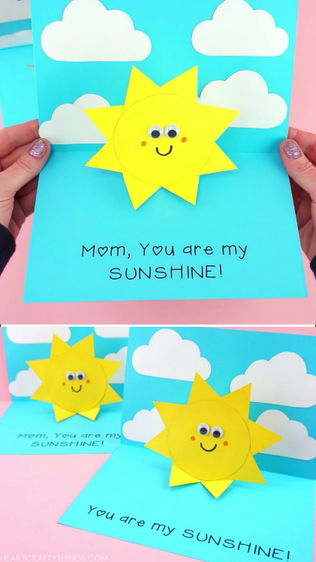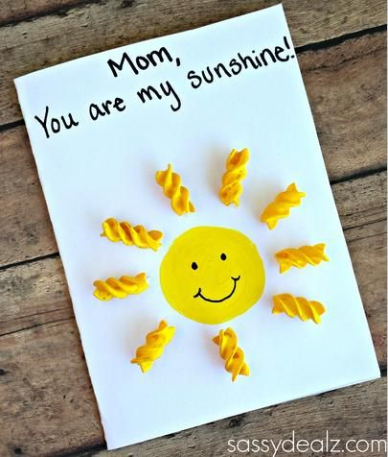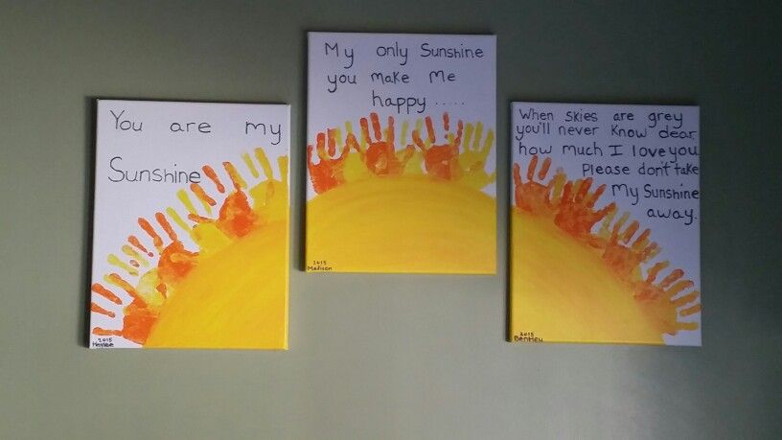

Extra activities:
Activity pack:
- Small Ball skills booklet: Practise overarm and underarm throwing. Set a challenge for yourself. Mark out where the ball lands each time and try your best to throw it further. Measure the distance you can throw the ball.
- Read and colour one of the Roald Dahl quotes and discuss what you think it means with your family.
- My home learning 2020 time capsule: Cover page and How I feel page.

Religion: log onto https://app.growinlove.ie/en/user/dashboard
username trial@growinlove.ie password growinlove
Click on 2nd class book.
Next theme- listen to the stories and sing the songs. You can print some worksheets aswell..
You can light a candle and say a prayer every day.
Prayers before and after communion.

