Junior Infants Work 25th – 29th May
Dear parents,
Here is this week’s school work for senior infants. I hope you are all keeping well and making the most of the time together at home. As always, I can be reached by email at infants.bweengns@gmail.com.
I enjoy seeing all your fabulous pictures of the school work and fun activities that you are doing each week so keep sending them. I am proud of all your hard work so well done everyone!
This week I am going to request that you send me images of certain activities during the week!
1. Just Phonics page 66
2. Busy at Maths page 103

Have a great week,
Miss Harrington

 | Monday | Tuesday | Wednesday | Thursday | Friday
Reading | Reading Comprehension Sheet 1 -at words. (If it’s not possible to print these, just read and answer the questions orally!)  Reading Eggs – One Lesson | Play BINGO with your red  words  Word game with Red Words – Scatter all your words on the floor. Throw an object such as a small teddy or a pair of rolled up socks. Can you read the word it lands on?  Reading Eggs – One Lesson | Reading Comprehension Sheet 2 -et words. Read and answer questions.  Reading Eggs – One Lesson | Play BINGO with all your words  Unscramble the words to make a sentence (activity at bottom of document)  Reading Eggs – One Lesson | Reading Comprehension Sheet 3 -an words.  Read and complete activities.  Reading Eggs – One Lesson
Phonics | New Letter this week: qu  What sound does it make? Listen to jolly song  https://www.youtube.com/watch?v=jxZx1WcHm_E  Brainstorm – What qu words can you think of? (quilt, queen, quiet, quarter, question, quack, quit, quill, quench, quiz)  Letter qu – Sounds Booklet page 32  (Draw some things that begin with the qu sound) | Qu sound – Just Phonics page 64  Draw, write, match and colour | Qu sound – Just Phonics page 65 | Just Phonics – page 66 (Write the correct initial sound under each picture) | Just Phonics – page 67 (Write the correct initial sound under each picture)
Writing | Green Letter Copy 2 – revise writing letters u and y | Chat about the day of the week and the weather.  Parent to write 2/3 lines of news on lined paper and allow space for child to copy writing. (See image)  Today is Tuesday.  It is a …….. day.  I watched/drew/played ….  He/She can draw a picture once finished. Lined paper is best and make sure you only use capital letters for names and at the start of a sentence.  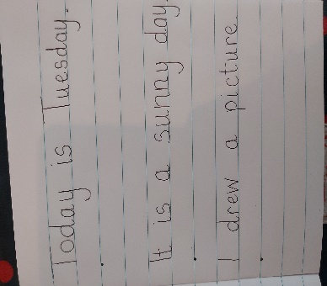 | Letter formation –letter q  All Write small book p.40 | Chat about the day of the week and the weather.  Parent to write 2/3 lines of news on lined paper and allow space for child to copy writing.  Today is Thursday.  It is a …….. day.  I watched/drew/played ….  He/She can draw a picture once finished. Lined paper is best and make sure you only use capital letters for names and at the start of a sentence. | Letter formation – letter q  All Write Now big book page 47
Skills Book | Skills Book page 60 – rhyming words | Skills Book – half page 61 | Skills Book – half page 61
Oral Language | Theme for this week again is linked to Aistear ‘The Garden Centre’ – In Oral Language we will focus on summer flowers and the lifecycle of a flower  Vocabulary– flower, petal, seed, sprouting seed, seedling, leaf, stem, roots, plant, soil, spade, trowel, rake, tree, garden, grow, pot, flower names (see flower hunt sheet on website)  Listen to the story again ‘The Tiny Seed’ by Eric Carle  https://www.youtube.com/watch?v=ls6wTeT2cKA  If you didn’t get a chance last week - Go on a plant and flower scavenger hunt around the garden, estate or village. (See hunt sheet on website) How many types of flowers can you see?  Can you remember all the parts of a flower? (petals, stem, roots, leaf, seeds)  Do you know what a plant needs to grow? (water, sunlight, soil)  Do you know how a plant grows? Have a look at the powerpoint on the lifecycle of a plant to learn some more. (on website)
Maths | This week we are focusing on adding 2 sets of objects where one set may be 0.  Lots of concrete work will be needed before book work eg:  using two plates and up to 5 pieces of fruit/veg/biscuits.  Put 3 items on 1 plate and 0 on the other. Now can you tell me how many there are altogether? Show that 3 and 0 make 3 or 0 and 3 make 3.  Do this as many times as you can with different arrangements.  Busy at Maths page 102 | Do the same activity as yesterday using teddies/dolls/toys etc.  Busy at Maths page 103 | Place 5 objects on the table and ask: How many objects are in this set? Partition (break up) the set by placing a pencil through the set to show 0 and 5 make 5. Ask your child to use the pencil to show you as many ways to make 5 as possible (including zero)  Busy at Maths page 104 | Game: What’s my number?  Have your child stand with his/her back to you. Trace one of the numerals 0-5 on his/her back. When your child guesses correctly, he/she can trace a numeral on your back. Take turns.  Busy at Maths page 105 | Play a game of Simon Says and add in some orders where they need to do something ‘zero times’ eg: Hop two times, turn around three times, blink your eyes four times, clap your hands zero times, touch your toes two times, reach for the sky zero times etc  Busy at Maths Small Book page 31 and 32

Other activities to try:
Gaeilge
This week we will look at Gaeilge vocab relating to ‘The Garden’ – ‘An Gairdín’

See video of the song ‘Cad atá sa ghairdín?’ on website.
Vocab:
gairdín (garden) crann (tree) balla (wall)
bláthanna (flowers) geata (gate) luascán (swing)
See-saw (see-saw) mór (big)

Phrases/Abairtí:
Cad atá sa ghairdín? (What is in the garden?)
Tá ___________ sa ghairdín. ( _________ is in the garden.)

Children can have fun singing along. They can also choose 4 or 6 items and draw them in a ‘BINGO card’. Parents can call irish words one by one and the children can cross the picture out if they have it.
They can also draw a simple ‘gairdín’ (garden) on a blank A4 page. Parents can call out the phrase ‘Cuir __________ (eg: crann) sa ghairdín’. Children then draw that item in the garden. Continue until all items are in the garden. Then ask the child the question: Cad atá sa ghairdín? And encourage them to answer with ‘Tá crann/geata etc sa ghairdín’.

Days of the week/Weather
Each morning in school we always start our day by reciting the days of the week and we fill in our calendar and weather chart so here are some questions to focus on each morning-
-What day is it today? What day was it yesterday? What day will tomorrow be?
-What month/season is it?
-What is the weather like today?
-Cén saghas lae é? (What sort of day is it?) Tá an lá ___________. fliuch(wet), fuar(cold), te (hot), tirim (dry), gaofar (windy), scamallach (cloudy). Tá an ghrian sa spéir. (The sun is out). Tá sé ag cur báistí. (It is raining)
PE
- Join The Body Coach Joe Wicks live every morning at 9am
- ‘Just Dance’ on Youtube has lots of fun dance activities for infants - ‘I Like to Move It’, ‘I’m a Gummy Bear’, ‘Trolls: Can’t Stop the Feeling’, ‘I’m Gonna Catch You’, ‘Shake it Off’, ‘Walking on Sunshine’.
- www.fyffesfitsquad.ie have online lessons daily.
- Why not try some kids yoga on the CosmicKids Yoga channel on youtube
- mollys_mini_movers provides free fun fitness classes for kids aged 3-8 every Wednesday on her Instagram page (10am – 3-5 years , 10.30am – 5-8years, 11:15 – Montessori level)

Aistear/Art
Our theme for Aistear is ‘At the Garden Centre’. Here are some activities around the theme to have some fun with:
- Role Play – Pretend play using whatever equipment is available to you at home eg: spades, trowels, rakes, flowers, seeds, hose, flower pots, watering can, garden gloves, equipment for selling items eg: cash register, money
- Messy Play – Plant some seeds (even the seeds from an apple will do) What tools do you need? – Have the opportunity to ‘garden’ and explore soil and using tools like trowels, rakes etc
- Playdough – Can you make some beautiful summer flowers using your playdough? Can you name the parts of your flower?
- Arts and Crafts – Draw/Paint/Create a picture of summer flowers using whatever arts and crafts materials you would like. Send me your creations- I would love to see

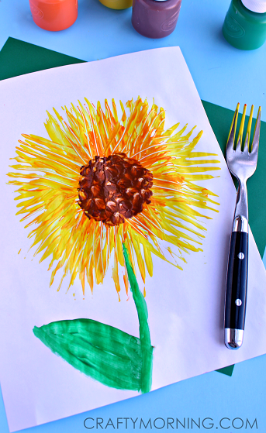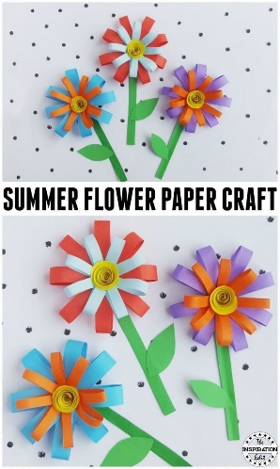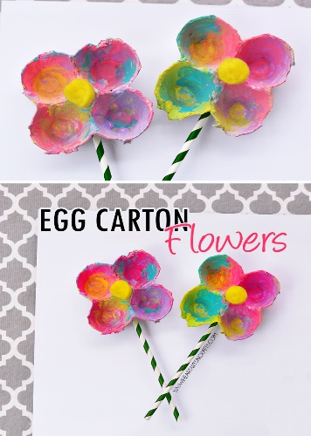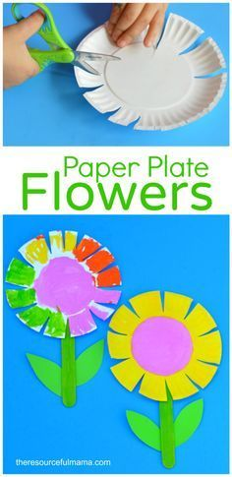
SESE
Lifecycle of a plant – Have a look at the powerpoint on the website and see if you can recall what is needed for a plant to grow. How does a plant grow? What happens?
Cut and Paste Activity on website – Can you order the lifecycle of a plant correctly?

Reading Comprehension Sheet 1
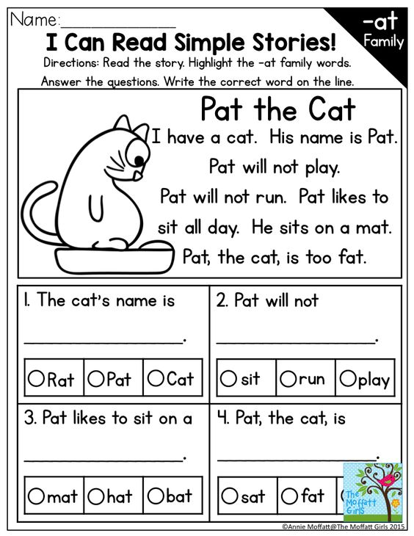

Reading Comprehension Sheet 2

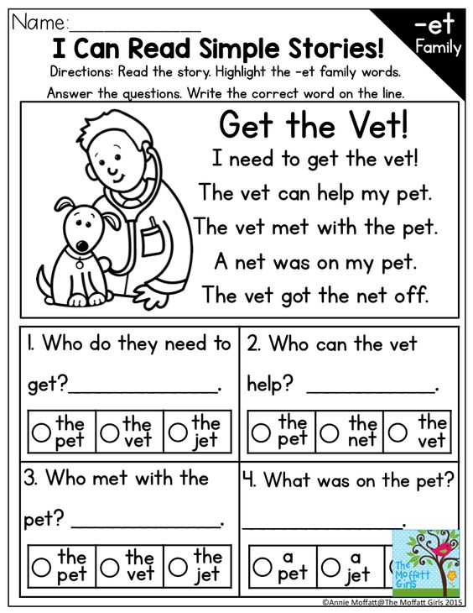
Reading Comprehension Sheet 3

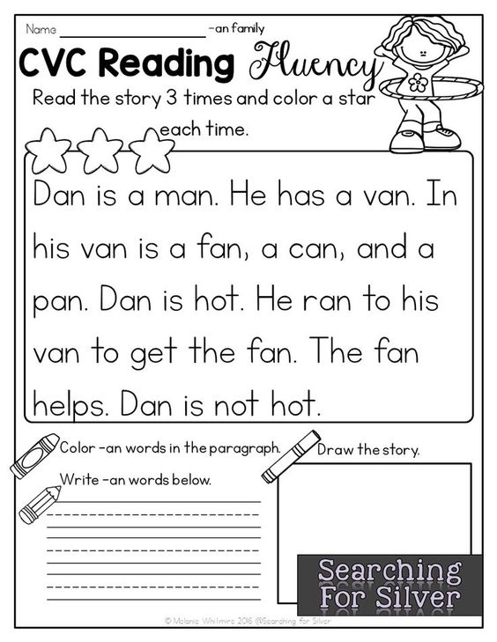

vet | The | with | pet
met | the

Pat | cat | fat | the
too | is

Cut up the words from each table. Can you rearrange the words to make a sentence?
If this is very easy get a timer and play beat the clock.

