Senior Infants Work 8th – 12th June
Dear all,
I hope you all had a lovely weekend. Here is this week’s school work for senior infants. There is a mix between book work and more practical fun activities that are in the pack that you all collected on Friday. As always, I can be reached by email at infants.bweengns@gmail.com. I enjoy seeing all your fabulous pictures of the school work and fun activities that you are doing each week so keep sending them. I am proud of all your hard work so well done everyone!
I just want to make ye aware too that Mrs. Sheehy has sent everyone an email about a new administrative system called Aladdin Connect that we intend to implement this week. It will enable us to send the end of year reports in a manner that is GDPR compliant.
Also, next week we hope to have a ‘virtual world book day’ so start getting your costumes ready to dress up as a character from your favourite book. We also intend to have a ‘virtual sports day’ next week so plenty fun in store for the whole family.
This week I am going to request that you send me images of certain activities during the week!
1. ‘Maths All Around Us, Maths in My Home’ – some or all of the activities can be sent.
2. Sounds in Action page 74

Have a great week,
Miss Harrington

Note :
Cork County Council Library and Arts Service is compiling an archive of this unusual era so that a record of our experiences will be available for future generations.

If any of your pupils or teachers is interested in sharing a story, poem or photo that encapsulates 2020, the closure of schools and the lockdown of our country during the COVID-19 crisis and what it means to them they can send it to localstudieslibrary@corkcoco.ie by Monday June 15th.

There are no prizes but the submitted pieces will be stored in an archive in the Local Studies Department of Cork County Library and will hopefully be a valuable resource for future historians when they study this time in history.

Use the word list that is in your pack with colour and number words. Read the list. Mark the words that are difficult and play some of the word games suggested over the past weeks to help reinforce these words

 | Monday | Tuesday | Wednesday | Thursday | Friday
Reading | Play roll the dice and tick off the word | Play the game roll the dice and write the word | Play the game roll the dice with two players | Pick two new words and two new number words and write a short story using these words (use the template) | See letter above from Cork county Council. Draw a picture, write a few short sentences, take a photo of life in lockdown. Send it into the county library. It will be kept in the library archives. You are now part of history. Send Ms. Harrington a photo.
Oral Language | Use the What Am I cards (on website)  Theme for this week again is linked to Aistear ‘The Garden Centre’ – In Oral Language we will focus on the theme minibeasts.  What can you remember about minibeasts from last week?  - A minibeast is a small animal or ‘creepy crawly’.  - Minibeasts have no backbone.  - Minibeasts do not have a skeleton on the inside.  - Some minibeasts have a hard shell to live in.  - Minibeasts can be found on land, water and air.  - There are a lot of different kinds of minibeasts. Can you name any?  Vocab–spider, slug, beetle, butterfly, woodlouse, daddy-long-legs, wasp, ladybird, snail, dragonfly, ant, worm, fly, bee, caterpillar, millipede, earwig,  Re-read to the powerpoint story ‘The Cautious Caterpillar’ (on website).  Some fun activities linked to the story (in pack) –  1. ‘Minibeast Hunt’. How many minibeasts can you see around the garden/estate?  2. ‘Minibeasts Sorting Activity’ – Can you cut, sort and paste the minibeasts into two categories? Minibeasts with legs/Minibeasts with no legs  3. Design your own butterfly
Phonics | Revise initial blends bl, br, cl, cr, dr, fr  Can you read the word lists?  Can you think of any other words beginning with these letter blends?  bl br cl Cr Dr fr  block black blue blob blast bled brick brush brown brother Brad clap clip club clock cliff class crab cross crib crash crisp crop drip drop drag drum dress drink frog from friend frost free Friday  Now can you find the corresponding page in your pack (Cut and Paste Blends – bl, br, cl, cr, dr, fr) and cut and paste the pictures under the correct letters.
Phonics | Sounds in Action – page 68 | Sounds in Action- page 69 | Sounds in Action- page 70 | Sounds in Action – page 71 | Sounds in Action – page 72
Skills Book | Make 2 or 3 strip books and read them.  What do you see? – page 49  My Dog – page 51
Writing | Writing template in pack – ‘What Can You See in the Summer Garden?’  Look at the picture. What is happening? Can you write some simple sentences about the picture  Eg: They will get wet. The ball is on the grass. The man has no shoes. Etc.  Use your green copy to practice your writing  Use your blue copy and do some capital letters
Maths | This week you will not have any Maths activities in your workbooks. All the activities are in your pack.  1. The Cautious Caterpillar Addition to 10 Colour by number  2. Minibeasts Block Diagram (Look at all the minibeasts at the top of the page – Count how many bees, ladybirds etc there are and colour the corresponding number of boxes on the bottom of the sheet.  3. Minibeast Colour by number Addition and Subtraction up to 10  4. Symmetrical Butterflies  5. ‘Maths All Around Us, Maths in My Home’ - Over the course of the week can you complete all these maths activities around the house?  You will have lots of fun

Other activities to try:
Days of the week/Weather
-What day is it today? What day was it yesterday? What day will tomorrow be?
-What month/season is it?
-What is the weather like today?
-Cén saghas lae é? (What sort of day is it?) Tá an lá ___________. fliuch(wet), fuar(cold), te (hot), tirim (dry), gaofar (windy), scamallach (cloudy). Tá an ghrian sa spéir. (The sun is out). Tá sé ag cur báistí. (It is raining)
PE
- Join The Body Coach Joe Wicks live every morning at 9am
- ‘Just Dance’ on Youtube has lots of fun dance activities for infants - ‘I Like to Move It’, ‘I’m a Gummy Bear’, ‘Trolls: Can’t Stop the Feeling’, ‘I’m Gonna Catch You’, ‘Shake it Off’, ‘Walking on Sunshine’.
- www.fyffesfitsquad.ie have online lessons daily.
- Why not try some kids yoga on the CosmicKids Yoga channel on youtube
- mollys_mini_movers provides free fun fitness classes for kids aged 3-8 every Wednesday on her Instagram page (10am – 3-5 years , 10.30am – 5-8years, 11:15 – Montessori level
Aistear/Art
Our theme for Aistear is ‘The Garden Centre/Minibeasts’. Here are some activities around the theme to have some fun with:
- Role Play – Pretend play using whatever equipment is available to you at home eg: spades, trowels, rakes, flowers, seeds, hose, flower pots, watering can, garden gloves, equipment for selling items eg: cash register, money
- Messy Play – Plant some seeds (even the seeds from an apple will do) What tools do you need? – Have the opportunity to ‘garden’ and explore soil and using tools like trowels, rakes etc
- Playdough – Can you make some minibeasts using your playdough?
- Arts and Crafts – Draw/Paint/Create a picture of minibeasts using whatever arts and crafts materials you would like. Here are some idease: toilet rolls bugs, paper plate minibeasts, printing minibeasts. Send me your creations- I would love to see
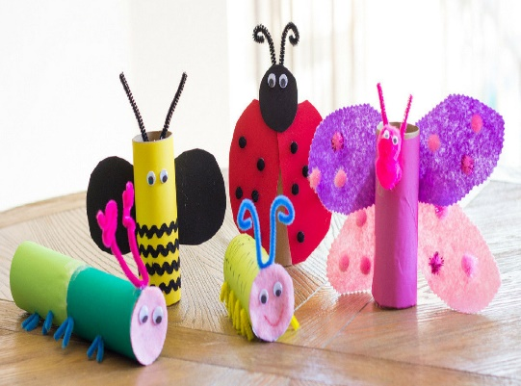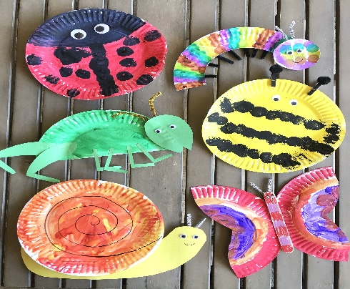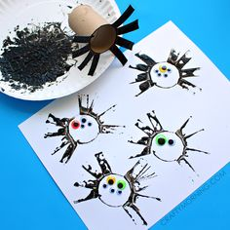
SESE - See activities on ‘minibeasts’ in Oral Language section above.

