Master Your Maths 5 Answers (Weeks 23-26) Daily Work and Weekly Tests

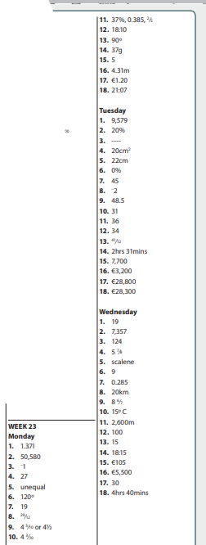

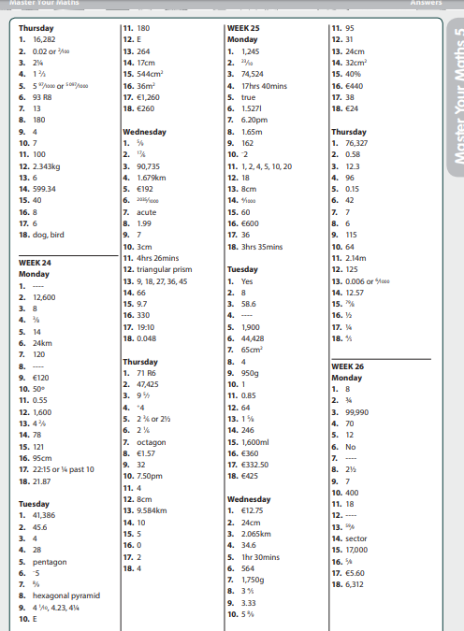

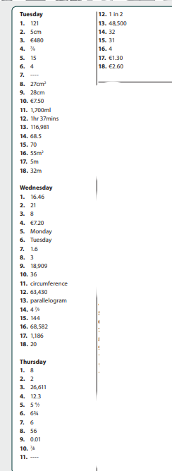

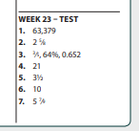

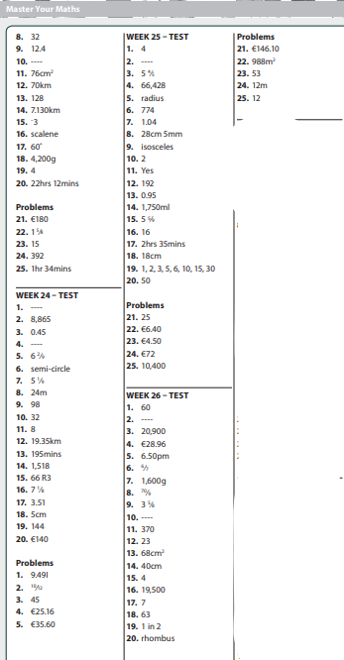

PAGE 110  1. 45mins  2. 10:10  3. 45mins  4. 1hr 55mins  5. 1hr 28mins  6. 1hr 39mins  7. 2 hrs 7mins  8. 1hr 09mins  9. 3hrs  10. 1hr 45mins  11. 10.17pm  12. 37mins  13. 3 hrs 25mins  14. 3hrs 51mins  15. 13hrs 47mins  Challenge: (a) Emer  (b) 32mins | PAGE 111  1.  (a) 5.43am  (b) 11.17am  (c) 3.40pm  (d) 7.54pm  (e) 11.23pm  2.  (a) 00:17  (b) 09:25  (c) 13:53  (d) 17:38  (e) 22:22  3.  (a) 00:25  (b) 07:40  (c) 15:35  (d) 17:37  (e) 10:26  (f) 22:27  4.  (a) 09:52  (b) 12:11  (c) 16:03  (d) 10:56  (e) 19:45  (f) 22:09  (g) 23:54  (h) 22:35  5.  (a) 09:27  (b) 12:12  (c) 14:49  (d) 17:34  (e) 20:12  6. 6hrs 43mins  7. 12hrs 52mins  8. 16:34  9. 10:47  10. 5hrs 40mins  11. 8hrs 50mins  Challenge: 5hrs 39mins | PAGE 135  (a) 20g, kitchen scales  (b) 600g, kitchen scales  (c) 2kg, spring balance  (d) 15g, kitchen scales  (e) 500kg, livestock scales  (f) 270g, kitchen scales  (g) 100g, kitchen scales  (h) 3,750kg, weigh bridge  (i) 25g, kitchen scales  (j) 350g, kitchen scales  Maths Fact: 55.2kg
Busy at Maths

Bun Go Barr
P101 D  - Lón  - Sóinseáil  - Teilifís  - Obair bhaile  - Leabhar  - Airgead | P.101 F  - Ag caint  - Ag scríobh  - Ag gáire  - Ag rith | P.102 I  - Tógfaidh  - Ní thógfaidh  - Ceannóidh  - Ní Cheannóidh  - Ólfaidh  - Ní Ólfaidh  - Ní bhaileoidh  - Baileoidh  - Cuirfidh  - Ní Chuirfidh  - Fanfaidh  - Ní Fhanfaidh

